**ECDC** SURVEY REPORT

**Testing strategies for HIV in blood, and tissues and cell donors within the EU/EEA**

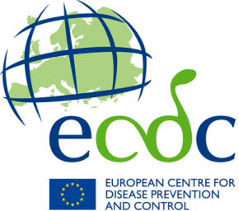

This report was developed in the context of developing guidelines for microbial safety of Substances of Human Origin by the European Centre for Disease Prevention and Control (ECDC).

**Credits and acknowledgements**

Modify text below. For authorship, see ECDC policy

Keep it short and straightforward.

Acknowledgements, if necessary, must be kept as short as possible (no more than a short paragraph).

If there is a large team of authors, names and institutions can be included in a table.

This text box will be deleted by the ECDC editorial team after completion of the document.

*Authors*Flavia Cunha, Francois-Xavier Lamy, Jenny Mohseni Skoglund.

This report was sent for consultation to the national focal points (NFP) of the ECDC substances of human origin (SoHO) network.

*Acknowledgements* [Optional]  
[Free text]

Suggested citation: As per ECDC technical report

Table of contents

**Table of contents**

Just a simple table of contents. The ECDC editors will format and update it.

This text box will be deleted by the ECDC editorial team after completion of the document.

Table of contents 3

Figures and tables 3

Abbreviations 5

1 Background 6

2 Methods 6

3 Survey results 7

Survey on HIV testing requirements in the EU/EEA – Blood 7

Survey on HIV testing requirements in the EU/EEA – Tissues and non-reproductive cells 13

Survey on HIV testing requirements in the EU/EEA – Reproductive cells 21

Conclusion 24

References 24

Annex 1. Survey on HIV testing requirements in the EU/EEA – Blood 25

Annex 2. Survey on HIV testing requirements in the EU/EEA – Tissues and Cells 29

Figures and tables

**Figures and tables**

List of the figures and tables in the report. Only used if there are more than two. The list of the figures and tables will be generated by the editors. Please leave this section blank.

This text box will be deleted by the ECDC editorial team after completion of the document.

Abbreviations

**Abbreviations**

List of abbreviations used in the report in alphabetical order. With the use of the terminology server at ECDC and the Document Management System, it should be easier to be consistent with the use of terms and abbreviations.

Note: Only press TAB once, even if your tabs are not aligned.

This text box will be deleted by the ECDC editorial team after completion of the document.

Ag Antigen

ECDC European Centre for Disease Prevention and Control

EEA European Economic Area

EU European Union

HBV Hepatitis B virus

HCV Hepatitis C virus

HIV Human immunodeficiency virus

ID Individual donation

LOD Limit of detection

MAR Medically assisted reproduction

MP Mini-pool

MS Member states

NA Not applicable

NAT Nucleic acid testing

NFP National focal point

NR Not reported

PCR Polymerase chain reaction

SoHO Substances of human origin

TMA Transcription-mediated amplification

WNV West Nile virus

Executive summary

**Executive summary**

Should stress the key messages from the report and correctly reflect on:

* The public health problem the study is addressing
* Objectives of the EQA scheme performed in relation to ECDC’s surveillance objectives
* Rationale of the study design, participants, time period
* Results obtained
* Key conclusions linked to the objectives, i.e. to what extent these were achieved and the impact on communicable disease surveillance

Taken/Proposed corrective actions and next steps

The executive summary must be a stand-alone piece as each year the summaries of key ECDC publications are compiled and published as a separate document. The language must be clear and straightforward to facilitate translation into other languages than English.

Tip: When reviewing the executive summary of your EQA report, ask yourself if you are targeting the objectives of the report. If needed, consult with ECDC’s Communication experts to address this issue jointly.

Note that if non-EU/EEA countries participated in the EQA, the results and conclusions should be presented in separate reports or sections of the report, i.e. EU/EEA countries, other countries, all participating laboratories.

This text box will be deleted by the ECDC editorial team after completion of the document.

**Background:** In the context of the new Regulation on standards of quality and safety for substances of human origin (SoHO) intended for human application, and the European Centre for Disease Prevention and Control (ECDC) has been designated as the expert institution for the communicable diseases field. ECDC is producing guidelines on the prevention of donor-derived transmission of human immunodeficiency virus (HIV) through SoHO.

**Methods:** Two online surveys were made available in the first semester of 2024 for the national focal points (NFP) for blood, tissues and non-reproductive cells and medically assisted reproduction (MAR) to provide information on national donor testing strategies for HIV.

**Results:** For the blood field, 27 countries responded, all reporting having HIV-1 and HIV-2 antibody detection established. In 22 countries, NAT testing is also part of the current testing strategy. Nine countries described performing more stringent testing methods besides the mandatory and other recommended strategies. The use of HIV-1 and HIV-2 combined nucleic acid testing (NAT) tests is currently in place in 21 countries. Regarding tissues and non-reproductive cells, the 18 countries responding reported having at least one method for HIV testing in place, primarily antibodies to HIV-1 and HIV-2. Nearly 40% of the countries perform more stringent testing methods than those mandatory in the directives and other recommended strategies. In this SoHO field, the use of HIV-1 and HIV-2 combined NAT tests is in place in eight countries. For MAR, 18 countries have established HIV testing strategies, with six countries running more stringent testing measures than those mandatory by directive and recommended at the national level.

**Conclusion:** Serological tests detecting antibodies for HIV-1 and HIV-2 are the most frequently reported test method through the EU/EEA and among the SoHO fields evaluated in this survey, but NAT testing is often included in the current testing strategy. Future assessments will allow the ECDC and member states (MS) to understand the impact of the ECDC guidelines on the donor testing strategies for HIV in the EU/EEA.

1 Background

On 27 May 2024, the Council adopted the new Regulation on standards of quality and safety for substances of human origin (SoHO) intended for human application[1]. Once in application, the regulation will repeal the Blood Directive (2002/98/EC) and the Tissues and Cells Directive (2004/23/EC). The Regulation will apply from 2027, three years after its adoption, with an extra year for specific provisions.

The proposed Regulation establishes the European Centre for Disease Prevention and Control (ECDC) as an expert body for developing and updating technical guidelines on the safety and quality of SoHOs from a communicable disease threat perspective. In this context, ECDC is developing guidelines for the prevention of donor-derived transmission of human immunodeficiency virus (HIV) through SoHO.

Surveys aimed to collect qualitative information from different European Union/European Economic Area (EU/EEA) countries were developed to describe testing requirements for HIV in the EU/EEA at the time of development of the ECDC guidelines. These surveys will be repeated in the coming years after the publication of guidelines developed by ECDC for the prevention of donor-derived transmission of HIV to assess their impact on testing requirements in EU/EEA countries.

2 Methods

Two online questionnaires (see Annex 1 and 2) were developed and published by ECDC in the EU Survey web application[2]. The questionnaires, covering testing requirements and national recommendations for HIV for blood, tissues and cells, and medically assisted reproduction (MAR), were shared with ECDC SoHO-Network national focal points (NFP) in early February by email.

The survey responses were extracted from the EU Survey application in May 2024 in Excel format. The answers to each question were summarised in tables, by frequency and proportion of responses, or represented in maps. The comments to the questions were extracted and summarised where relevant.

3 Survey results

# Survey on HIV testing requirements in the EU/EEA – Blood

The survey was shared with the NFPs of all 30 EU/EEA countries. Responses were obtained from 27 countries (participation rate of 90%): Austria, Belgium, Bulgaria, Croatia, Cyprus, Czechia, Denmark, Estonia, Finland, France, Germany, Hungary, Iceland, Italy, Latvia, Liechtenstein, Luxembourg, Malta, Netherlands, Norway, Poland, Portugal, Romania, Slovakia, Slovenia, Spain and Sweden.

As of May 2024, no data were provided for Greece, Ireland, and Lithuania, and no results from these countries were included in the report.

1. **Organisation of the National Transfusion Service**
   1. Is there a centralised blood service in your country?

The presence or absence of centralised blood services in the EU/EEA countries is represented in Figure 1.

###### Figure 1. Existence of centralised blood services in the EU/EEA countries.

* 1. What is the status of the providers of the transfusion service?

The distribution of providers of transfusion services between public and private sectors in the EU/EEA countries is represented in Figure 2.

###### Figure 2. Status of transfusion services providers in the EU/EEA.

1. **What are the HIV testing strategies required in your country for blood donors: legally binding or recommended on the national or regional level?**

Twenty-seven countries provided information for this question. The testing strategies reported for blood donors, legally binding and those that are recommended (at the national or regional level), are presented in Table 1.

###### Table 1. HIV testing strategies in the EU/EEA for blood donors.

| **Country** | **Anti-HIV-1/2** | **HIV p24Ag** | **HIV NAT – ID** | **HIV NAT - MP** | **HIV NAT (ID or MP not specified)** | **Minimum LOD for NAT** |
| --- | --- | --- | --- | --- | --- | --- |
| Austria |  |  |  |  |  | NR |
| Belgium |  |  |  |  |  | NR |
| Bulgaria |  |  |  |  |  | 200 |
| Croatia |  |  |  |  |  | NR |
| Cyprus |  |  |  |  |  | NR |
| Czechia |  |  |  |  |  | 500 |
| Denmark |  |  |  |  |  | 75 |
| Estonia |  |  |  |  |  | 10000 |
| Finland |  |  |  |  |  | NR |
| France |  |  |  |  |  | No requirement |
| Germany |  |  |  |  |  | 10a |
| Greece |  |  |  |  |  |  |
| Hungary |  |  |  |  |  | 7 |
| Iceland |  |  |  |  | b | NR |
| Ireland |  |  |  |  |  |  |
| Italy |  |  |  |  |  | NR |
| Latvia |  |  |  |  |  | NR |
| Liechtensteinc |  |  |  |  |  | NR |
| Lithuania |  |  |  |  |  |  |
| Luxembourg |  |  |  |  |  | NR |
| Malta |  |  |  |  |  | 10000 |
| Netherlands |  |  |  |  |  | 970 |
| Norway |  |  |  |  |  | NR |
| Poland |  |  |  |  |  | NR |
| Portugal |  |  |  |  |  | No requirement |
| Romania |  |  |  |  |  | NR |
| Slovakia |  |  |  |  |  | 20 |
| Slovenia |  |  |  |  |  | No requirement |
| Spain |  | d |  |  |  | NR |
| Sweden |  |  |  |  |  | NR |

Ag: antigen. HIV: human immunodeficiency virus. ID: individual donation. LOD: limit of detection. MP: mini-pool. NAT: nucleic acid test. NR: not reported.

a Note from NFP for Germany: “*If quarantine storage of fresh frozen plasma is waived, an ID or minipool HIV-1-NAT screening with a sensitivity of at least 3.300 IU/ml is required.”*

bNote from NFP for Iceland: *“Currently, HIV NAT testing of blood donors is neither required nor carried out at the Blood Bank in Iceland. The Ministry of Health has decided to implement NAT screening of all blood donors for HIV, HBV and HCV starting in 2025. The test will be carried out at the Department of Microbiology and Virology at Landspitali University Hospital. Therefore, NAT screening for HBV, HCV and HIV will be a mandatory test for every blood donor by 2025.”*

c Note from NFP from Liechtenstein: “*Blood and blood products from Liechtenstein are tested and processed in Austria. Please refer to the Austrian requirements and rules*.”

d Note from NFP for Spain: *“Currently, all commercial tests are combined HIV p24Ag + Ab.”*

|  |  |
| --- | --- |
|  | Legally binding testing strategy |
|  | Testing is not legally binding |
|  | No data |

|  |  |
| --- | --- |
|  | National recommendation |
|  | Regional recommendation |
|  | No recommendations at the national/regional level |

1. **Practice in place**
   1. Does any blood establishment apply more stringent measures regarding HIV testing than what is legally required or recommended?

Twenty-five out of 27 countries responded to this question. Nine countries (33%) report more stringent measures beyond the mandatory or recommended ones; the additional tests per country, as well as the proportion of donations that are tested with these additional measures, are reported in Table 2.

###### Table 2. Additional tests applied beyond mandatory/recommended HIV testing strategy and proportion of donations tested with additional methods, EU/EEA.

| **Country** | **More stringent measures? (Y/N)** | **If yes, which ones:** | | | | | | |
| --- | --- | --- | --- | --- | --- | --- | --- | --- |
| **Anti-HIV-1/2 (%)** | **HIV p24Ag (%)** | **HIV-1 NAT ID or pool not specified (%)** | **HIV-1 NAT pool (%)** | **HIV-1 NAT ID (%)** | **HIV-2 NAT (%)** | **Other (%)** |
| Austria | N |  |  |  |  |  |  |  |
| Belgium | Y |  |  |  | X |  |  | Xa |
| Bulgaria | N |  |  |  |  |  |  |  |
| Croatia | N |  |  |  |  |  |  |  |
| Cyprus | Y |  | X  (100) |  | X  (100) |  | X  (100) |  |
| Czechia | Y |  | X |  |  |  |  |  |
| Denmark | Y |  | X  (100) |  |  |  |  |  |
| Estonia | N |  |  |  |  |  |  |  |
| Finland | N |  |  |  |  |  |  |  |
| France | N |  |  |  |  |  |  |  |
| Germany | Y |  | X  (>90) |  |  |  | X  (>70) |  |
| Greece |  |  |  |  |  |  |  |  |
| Hungary | Yb |  |  |  |  |  |  |  |
| Iceland | N |  |  |  |  |  |  |  |
| Ireland |  |  |  |  |  |  |  |  |
| Italy | N |  |  |  |  |  |  |  |
| Latvia | - | - | - | - | - | - | - | - |
| Liechtenstein | N |  |  |  |  |  |  |  |
| Lithuania |  |  |  |  |  |  |  |  |
| Luxembourg | N |  |  |  |  |  |  |  |
| Malta | N |  |  |  |  |  |  |  |
| Netherlands | Y |  | X  (100) |  |  |  |  |  |
| Norway | N |  |  |  |  |  |  |  |
| Poland | N |  |  |  |  |  |  |  |
| Portugal | N |  |  |  |  |  |  |  |
| Romania | Y |  |  |  |  | X | X |  |
| Slovakia | Y |  |  | X  (»75) |  |  | X  (»75) |  |
| Slovenia | N |  |  |  |  |  |  |  |
| Spain | N |  |  |  |  |  |  |  |
| Sweden | N |  |  |  |  |  |  |  |

Ag: antigen. HIV: human immunodeficiency virus. ID: individual donation. N: no. NAT: nucleic acid test. Y: yes.

a Note from NFP for Belgium: “*In case of positive serology, and if NAT ID and confirmation test are negative, blood products are discarded, and the donor is tested one month later. In case of the same results one month later, the donor is excluded (false positive). Use of combination test: Ag-p24 + Ab-HIV1/2.”*

b Note from NFP for Hungary: *“The same test is used for one sample.”*

CNote from NFP for Latvia: *“The use of more stringent measures is not prohibited, but we don't have information at the national level.”*

|  |  |
| --- | --- |
|  | No data |

1. **Use of HIV-1 and HIV-2 NAT combined tests**
   1. Are HIV-1 and HIV-2 NAT combined tests used in your country?

Twenty-four out of 27 countries responded to this question. NAT combined tests for HIV-1 and HIV-2 are in use in 21 countries. The tests’ descriptions, as well as the rationale for the use of HIV-1 and HIV-2 combined NAT tests per country are reported in Table 3.

###### Table 3. Use of HIV-1 and HIV-2 combined NAT tests per country, EU/EEA.

| **Country** | **Use of HIV-1 and HIV-2 combined NAT tests** | **Description of the HIV-1 and HIV-2 combined NAT tests in use** | **Rationale for the use of HIV-1 and HIV-2 combined NAT tests** |
| --- | --- | --- | --- |
| Austria | Yes | Cobas® MPX Test, Roche. | *Legally binding.* |
| Belgium | Yes |  |  |
| Bulgaria | Yes | Procleix® Ultrio Elite Assay, Grifols. | *The use of HIV-1 NAT has reduced the window period of detection by 6 to 11 days in donations tested individually.*  *The residual risk for potential HIV-2 transfusion is estimated to be extremely low, but it has not been possible to confirm these estimates directly. Screening for HIV-2 RNA should reduce the risk even further.* |
| Croatia | Yes | Procleix® Ultrio Elite Assay, Grifols. | *Possible risk of transmission in migrant workers (for example, seafarers), travellers, and migrants.*  *HIV-1/2 NAT is legally binding in Croatia.* |
| Cyprus | Yes | Procleix® Ultrio Elite Assay, Grifols | *Minimising the window period and having a safer technique for the transfused patients.  To use the minimal blood sample volume for both tests.* |
| Czechia | No | NA | NA |
| Denmark | Yes | Procleix® Ultrio Elite Assay, Grifols  (4 out of 5 regions). NAT testing from Roche (one region). | *National tender.* |
| Estonia | Yes | Procleix® Ultrio Elite Assay, Grifols. | *HIV-1 and HIV-2 may be discriminated by using rapid immunoassays. The residual risk for potential HIV-2 transfusion is estimated to be extremely low, but it has not been possible to confirm these estimates directly. Screening for HIV-2 RNA should reduce the risk even further.* |
| Finland | Yes | Cobas® MPX Test, Roche. | *MPX test is a multiplex assay which detects both HIV-1 and -2 simultaneously.* |
| France | Yes | Cobas® MPX Test (on Cobas® 8800 System), Roche.  Procleix® UltrioPlex E Assay, Grifols.  *(both CE-marked assays detect HIV-1 and HIV-2 RNA)* | *The rationale concerns the application of the COMMISSION IMPLEMENTING DECISION (EU) 2019/1244 from July 1, 2019, amending Decision 2002/364/EC as regards requirements for combined tests of HIV and HCV antigens and antibodies and with regard to the requirements applicable to nucleic acid amplification techniques as they relate to reference materials and qualitative HIV tests [notified under number C(2019) 4632].* |
| Germany | Yes | Procleix® Ultrio Elite Assay, Grifols; Procleix® UltrioPlex E Assay, Grifols; Cobas® MPX Test, Roche;  Cobas ® TaqScreen MPX Test, Roche; PoET® HIV Test, GFE Blut mbH. | *HIV-2-NAT testing is included in the combined tests (multiplex tests), which are commercially available but are not legally binding due to a lack of epidemiological risk.* |
| Greece |  |  |  |
| Hungary | Yes | Cobas® MPX Test (on Cobas® 6800 System), Roche. | *National tender.* |
| Iceland | No | NA | NA |
| Ireland |  |  |  |
| Italy | Yes | *Either real-time PCR or TMA can be used, depending on local choices.* | *Improving towards avoiding HIV-1 and HIV-2 window period donations.* |
| Latvia | Yes | Procleix® Ultrio Elite Assay, Grifols. |  |
| Liechtenstein | Yes |  | *Blood and blood products from Liechtenstein are tested and processed in Austria. Please refer to the Austrian requirements and rules.* |
| Lithuania |  |  |  |
| Luxembourg |  |  |  |
| Malta | Yes | Procleix® Ultrio Elite Assay, Grifols. | *A combined test is done based on financial and time management.* |
| Netherlands | Yes | Cobas® MPX Test (on Cobas® 6800 System), Roche. | *Both viruses are relevant for transfusion safety.* |
| Norway | No | NA | NA |
| Poland | Yes | Procleix® Ultrio Elite Assay, Grifols;  Cobas® MPX Test, Roche. | *Used assays can detect both forms of the virus (using such assays is not connected with the epidemiological situation).* |
| Portugal | Yes | Cobas® MPX Test (on Cobas® 5800/6800/8800 Systems for HIV-1 subgroup M (the most prevalent in Portugal), for HIV-1 subgroup O and HIV-2. | *Country's HIV epidemiology and demographic profile. The prevalence of HIV-2 in some African countries is more than 1%, and HIV-2 is a concern due to the mixing of Portuguese with other populations, especially African ones, with which Portugal has always had close contact, with strong migratory movements.* |
| Romania | Yes | Cobas® MPX Test | *Blood establishments using NAT testing are under the Ministry of Defence; we do not have this information.* |
| Slovakia | Yes | Procleix® UltrioPlex E Assay, Grifols. |  |
| Slovenia | Yes | Procleix® Ultrio Elite Assay, Grifols. | *All the major players on the market provide combined tests.* |
| Spain | Yes | PCR, Roche; TMA, Grifols. |  |
| Sweden |  |  |  |

HIV: human immunodeficiency virus. ID: individual donation. NA: not applicable. NAT: nucleic acid test. PCR: polymerase chain reaction. TMA: transcription-mediated amplification.

|  |  |
| --- | --- |
|  | No data |

# Survey on HIV testing requirements in the EU/EEA – Tissues and non-reproductive cells

The survey was shared with the 30 EU/EEA countries. Responses were obtained from 21 countries (participation rate of 70%): Austria, Belgium, Bulgaria, Cyprus, Czechia, Denmark, Finland, France, Germany, Greece, Iceland, Liechtenstein, Lithuania, Malta, Netherlands, Norway, Poland, Portugal, Romania, Spain, and Sweden.

As of May 2024, no data was provided for Croatia, Estonia, Hungary, Ireland, Italy, Latvia, Luxembourg, Slovakia, and Slovenia, and no results from these countries are included in the report.

1. **Organisation of the National Transplantation Service for tissues and non-reproductive cells**
   1. What is the status of the microbiology laboratories responsible for donor screening?

The distribution of microbiology laboratories performing donor screening for tissues and non-reproductive cells between public and private sectors in the EU/EEA countries is represented in Figure 3.

###### Figure 3. Status of microbiology laboratories performing donor screening in the EU/EEA.

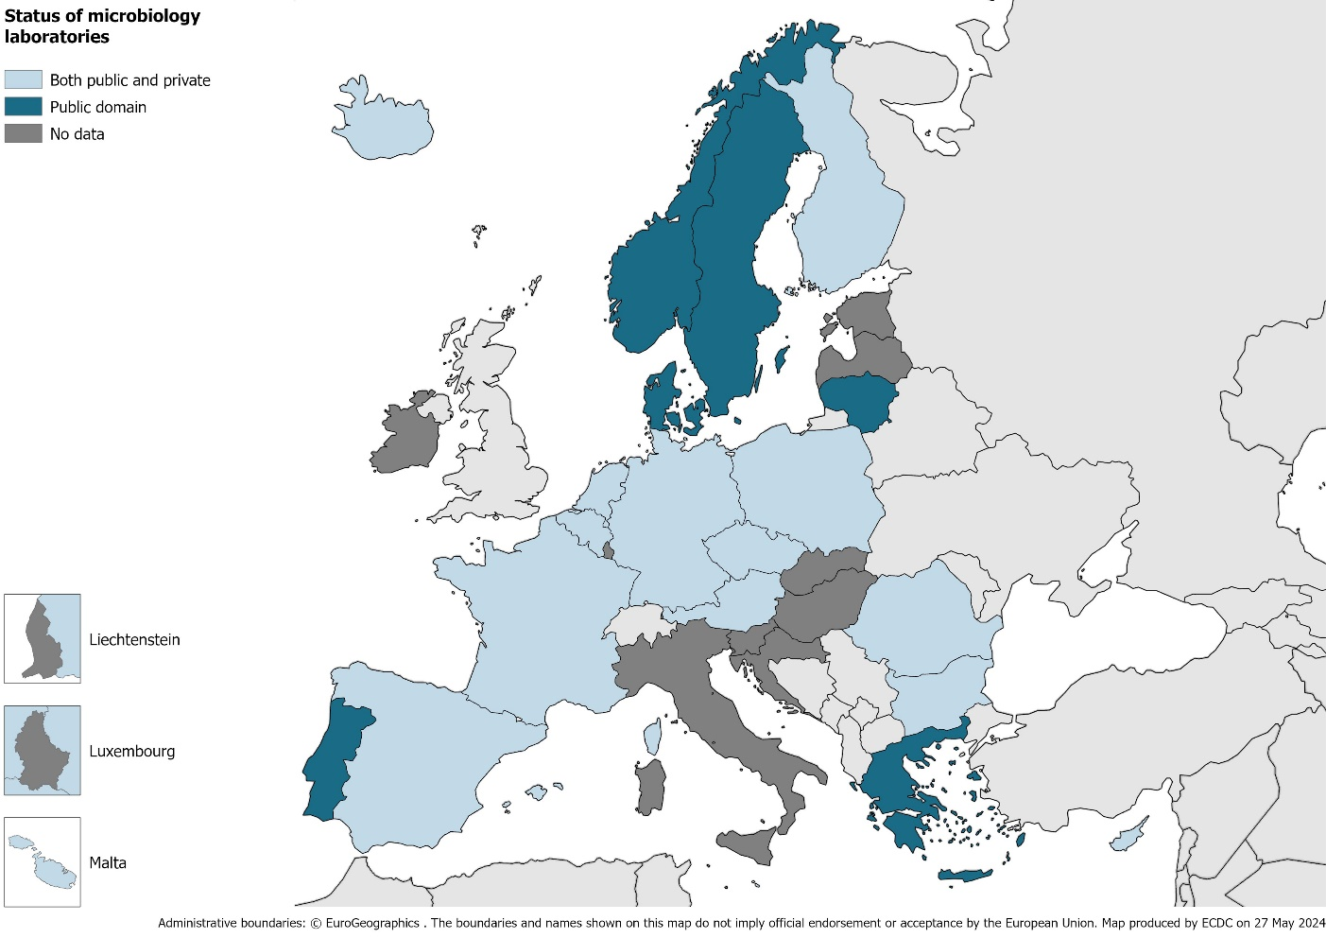

* 1. Are some of the microbiology laboratories responsible for donor screening able to provide results at any time or day (i.e., 24/7)?

Seventeen countries responded to this question, with 13 countries describing having real-time or low-latency results communication concerning donor screening (Figure 4).

###### Figure 4. Microbiology laboratories reporting real-time/low-latency results concerning donor screening, EU/EEA.

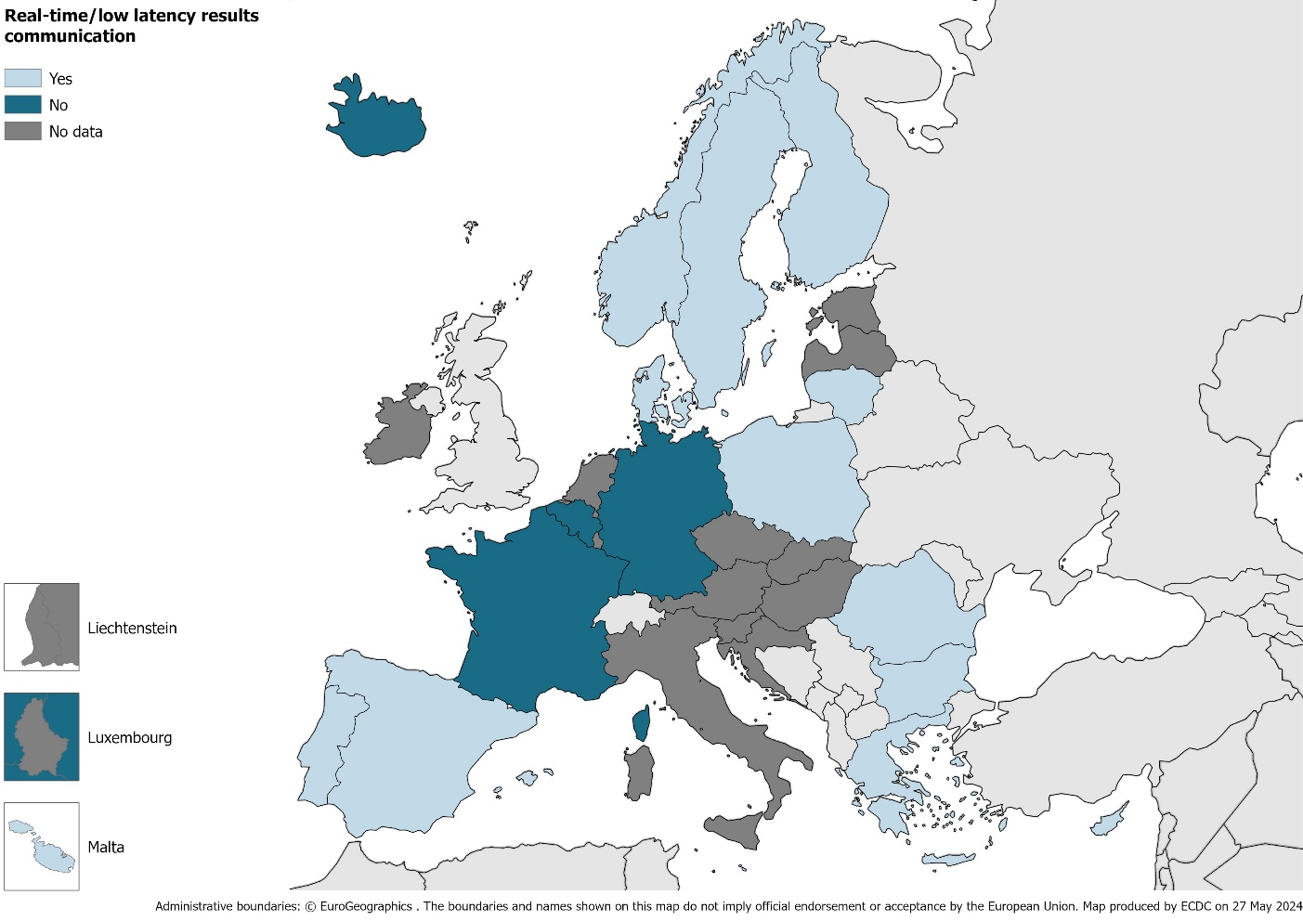

From the countries above, six reported the number of microbiology laboratories with the ability to report donor screening results at any time or day (i.e., 24/7) (Figure 5).

###### Figure 5. Number of microbiology laboratories reporting real-time/low-latency results concerning donor screening, EU/EEA.

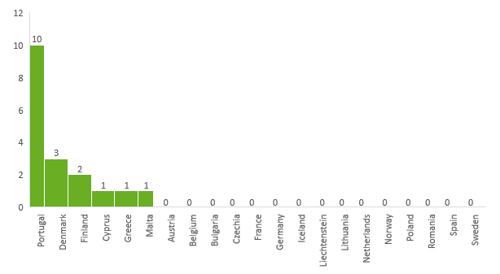

1. **What are the HIV testing strategies required in your country for tissues and non-reproductive cell donors: legally binding or recommended on the national or regional level?**

* Living donors

Of the 21 countries that participated in the survey, 18 (86%) reported data on the HIV testing strategy for tissues and non-reproductive cell donors.

The testing strategies reported for living donors, legally binding and those that are recommended (at the national or regional level) are presented in Table 4.

###### Table 4. HIV testing strategies in the EU/EEA for living donors of tissues and non-reproductive cells in the EU/EEA.

| **Country** | **Anti-HIV-1/2** | **HIV p24Ag** | **HIV NAT – ID** | **HIV NAT - MP** | **HIV NAT (ID or MP not specified)** |
| --- | --- | --- | --- | --- | --- |
| Austria |  |  |  |  |  |
| Belgiuma |  |  |  |  |  |
| Bulgaria |  |  |  |  |  |
| Croatia |  |  |  |  |  |
| Cyprus |  |  |  |  |  |
| Czechia |  |  |  |  |  |
| Denmarkb |  |  |  |  |  |
| Estonia |  |  |  |  |  |
| Finland |  |  |  |  |  |
| France |  |  |  |  |  |
| Germany |  |  |  |  |  |
| Greece |  |  |  |  |  |
| Hungary |  |  |  |  |  |
| Iceland |  |  |  |  |  |
| Ireland |  |  |  |  |  |
| Italy |  |  |  |  |  |
| Latvia |  |  |  |  |  |
| Liechtensteinc | NA | NA | NA | NA | NA |
| Lithuaniad |  |  |  |  |  |
| Luxembourg |  |  |  |  |  |
| Malta |  |  |  |  |  |
| Netherlandse |  |  |  |  |  |
| Norway |  |  |  |  |  |
| Poland |  |  |  |  |  |
| Portugal |  |  |  |  |  |
| Romania |  |  |  |  |  |
| Slovakia |  |  |  |  |  |
| Slovenia |  |  |  |  |  |
| Spain |  |  |  |  |  |
| Swedenf |  |  |  |  |  |

Ag: antigen. HIV: human immunodeficiency virus. ID: individual donation. LOD: limit of detection. MP: mini-pool. NA: not applicable. NAT: nucleic acid test.

a Note from NFP for Belgium: *“A. When cells and tissues from living donors and for allogeneic use can be stored for long periods, it is necessary to take another blood sample and test for anti-HIV-1/2 after 180 days. If the tests are repeated, the donation sample can be collected within 30 days before and within seven days after the donation. When cells and tissues from living donors and for allogeneic use cannot be stored for long periods, and retest is impossible, NAT will be carried out, like those which apply to deceased donors, unless the treatment includes an inactivation step validated for the virus in question. If, in the case of a living donor, the donation sample, as defined above, is tested with HIV NAT, it is then not necessary to examine a second blood sample. Likewise, it is unnecessary to repeat the test when the transformation procedure includes an inactivation step validated for the infectious agent.”*

b Note from NFP for Denmark: *“HIV NAT test is a must if donations are released without a re-test of anti-HIV-1/2 six months after donation. All laboratories use Ab-Ag combined tests for the serology testing.”*

c Note from NFP for Liechtenstein: *“Due to the small size of the country, Liechtenstein has no national transplantation service.”*

d Note from NFP for Lithuania: “*HIV NAT is not mandatory for living donors if serology tests are repeated after 180 days.”*

e Note from NFP for the Netherlands: *“Legally binding: anti-HIV-1/2, for living tissue donors to be repeated 180 days after donation (second sample can be replaced by NAT testing of the donation sample).”*

f Note from NFP for Sweden: *“HIV NAT is used when tests cannot be repeated.”*

|  |  |
| --- | --- |
|  | Legally binding testing strategy |
|  | Testing is not legally binding |
|  | No data |

|  |  |
| --- | --- |
|  | National recommendation |
|  | Regional recommendation |
|  | No recommendations at the national/regional level |

* Deceased donors

The testing strategies reported for deceased donors, legally binding and those recommended (at the national or regional level) are presented in Table 5.

###### Table 5. HIV testing strategies in the EU/EEA for deceased donors in the EU/EEA.

| **Country** | **Anti-HIV-1/2** | **HIV p24Ag** | **HIV NAT – ID** | **HIV NAT - MP** | **HIV NAT (ID or MP not specified)** |
| --- | --- | --- | --- | --- | --- |
| Austria |  |  |  |  |  |
| Belgiuma |  |  |  |  |  |
| Bulgaria |  |  |  |  |  |
| Croatia |  |  |  |  |  |
| Cyprus |  |  |  |  |  |
| Czechia |  |  |  |  |  |
| Denmark |  |  |  |  |  |
| Estonia |  |  |  |  |  |
| Finland |  |  |  |  |  |
| France |  |  |  |  |  |
| Germany |  |  |  |  |  |
| Greece |  |  |  |  |  |
| Hungary |  |  |  |  |  |
| Iceland |  |  |  |  |  |
| Ireland |  |  |  |  |  |
| Italy |  |  |  |  |  |
| Latvia |  |  |  |  |  |
| Liechtensteinb | NA | NA | NA | NA | NA |
| Lithuania |  |  |  |  |  |
| Luxembourg |  |  |  |  |  |
| Malta |  |  |  |  |  |
| Netherlands |  |  |  |  |  |
| Norway |  |  |  |  |  |
| Poland |  |  |  |  |  |
| Portugal |  |  |  |  |  |
| Romania |  |  |  |  |  |
| Slovakia |  |  |  |  |  |
| Slovenia |  |  |  |  |  |
| Spain |  |  |  |  |  |
| Sweden |  |  |  |  |  |

Ag: antigen. HIV: human immunodeficiency virus. ID: individual donation. LOD: limit of detection. MP: mini-pool. NAT: nucleic acid test.

a Note from NFP for Belgium*: “B. In deceased donors, anti-HIV-1/2 and HIV-1 NAT are carried out unless the transformation procedure includes an inactivation step that is validated for HIV.”*

b Note from NFP for Liechtenstein: *“Due to the small size of the country, Liechtenstein has no national transplantation service.”*

|  |  |
| --- | --- |
|  | Legally binding testing strategy |
|  | Testing is not legally binding |
|  | No data |

|  |  |
| --- | --- |
|  | National recommendation |
|  | Regional recommendation |
|  | No recommendations at the national/regional level |

* 1. Is molecular testing in pools authorised for tissues and non-reproductive cell donors?

HIV molecular pool testing for tissues and non-reproductive cell donors is authorised in four countries (Austria, Greece, the Netherlands and Poland). However, in the Netherlands, it is only authorised for living donors.

* 1. If a minimum limit of detection for HIV NAT is required, please specify: (consider 1 copy HIV-1 = 2 IU/mL)

None of the 21 countries provided estimates for minimum LOD for HIV NAT for tissues and non-reproductive cells. The following notes were added by the NFPs for the countries below:

* Cyprus: *“Limits of detection for HIV NAT are not regulated.”*
* Germany: *“There is no official definition for testing tissue donors. The specifications valid for blood donor testing (HIV-1: 10.000 IU/mL) are used as a basis.”*
* Portugal: *“There is no national legally binding or recommended minimum LOD for HIV NAT.”*

1. **Practice in place**
   1. Does any establishment apply more stringent measures regarding HIV testing than what is legally required or recommended?

Eighteen out of 21 countries responded to this question. Seven countries (39%) apply more stringent measures beyond mandatory or recommended ones; the additional tests per country are reported in Table 6.

###### Table 6. Additional tests applied beyond mandatory/recommended HIV testing strategy in tissues and non-reproductive cells donors screening, EU/EEA.

| **Country** | **More stringent measures? (Y/N)** | **If yes, which ones:** | | | |
| --- | --- | --- | --- | --- | --- |
| **Anti-HIV-1/2** | **HIV p24Ag (+/- anti-HIV-1/2)** | **HIV-1 NAT** | **HIV-2 NAT** |
| Austria | Y |  |  | X | X |
| Belgium | N |  |  |  |  |
| Bulgaria | N |  |  |  |  |
| Croatia |  |  |  |  |  |
| Cyprus | N |  |  |  |  |
| Czechia | Y |  |  | X |  |
| Denmark | Y |  | X |  | Xa |
| Estonia |  |  |  |  |  |
| Finland | N |  |  |  |  |
| France | N |  |  |  |  |
| Germany | Y |  |  | Xb |  |
| Greece | N |  |  |  |  |
| Hungary |  |  |  |  |  |
| Iceland | N |  |  |  |  |
| Ireland |  |  |  |  |  |
| Italy |  |  |  |  |  |
| Latvia |  |  |  |  |  |
| Liechtensteinc | NA | NA | NA | NA | NA |
| Lithuania | N |  |  |  |  |
| Luxembourg |  |  |  |  |  |
| Malta | N |  |  |  |  |
| Netherlands | Y | X | X | X | X |
| Norway | N |  |  |  |  |
| Poland | Y |  |  | X | X |
| Portugal | N |  |  |  |  |
| Romania | Y |  |  | X | X |
| Slovakia |  |  |  |  |  |
| Slovenia |  |  |  |  |  |
| Spain |  |  |  |  |  |
| Sweden |  |  |  |  |  |

Ag: antigen. HIV: human immunodeficiency virus. N: no. NA: not applicable. NAT: nucleic acid test. Y: yes.

a Note from NFP for Denmark: *“4 of 5 regions use HIV1 / 2 NAT test - but HIV-2 NAT is not mandatory.”*

b Note from NFP for Germany: *“For certain tissues such as cardiovascular tissues, musculoskeletal tissues and amniotic membranes (except for tissues for which a validated inactivation procedure is used).”*

c Note from NFP for Liechtenstein: *“Due to the small size of the country, Liechtenstein has no national transplantation service.”*

|  |  |
| --- | --- |
|  | No data |

* 1. To the best of your knowledge, are the tests used for HIV screening validated for deceased donors?

Seventeen out of 21 countries responded to this question. Ten (59%) confirmed that the tests used for HIV screening are validated for application in deceased donors. The type of validated tests is presented in Table 7.

###### Table 7. HIV screening test validated for deceased donors, EU/EEA.

| **Country** | **Anti-HIV-1/2** | **HIV p24Ag** | **HIV-1 NAT** | **HIV-2 NAT** | **Other** |
| --- | --- | --- | --- | --- | --- |
| Austria |  |  | X | X |  |
| Belgium |  |  |  |  | Xa |
| Bulgaria |  |  |  |  |  |
| Croatia |  |  |  |  |  |
| Cyprusb |  |  |  |  |  |
| Czechia | X | X |  |  |  |
| Denmark | X | X | X | X |  |
| Estonia |  |  |  |  |  |
| Finland |  |  |  |  |  |
| France |  |  |  |  |  |
| Germany | X |  | X |  |  |
| Greece |  |  |  |  |  |
| Hungary |  |  |  |  |  |
| Iceland |  |  |  |  |  |
| Ireland |  |  |  |  |  |
| Italy |  |  |  |  |  |
| Latvia |  |  |  |  |  |
| Liechtensteinc | NA | NA | NA | NA | NA |
| Lithuania | X | X | X |  |  |
| Luxembourg |  |  |  |  |  |
| Malta |  |  |  |  |  |
| Netherlands | X | X | X | X |  |
| Norwayd |  |  |  |  |  |
| Poland | X | X | X | X |  |
| Portugale |  |  |  |  |  |
| Romania | X |  | X | X |  |
| Slovakia |  |  |  |  |  |
| Slovenia |  |  |  |  |  |
| Spain |  |  |  |  |  |
| Sweden |  |  |  |  |  |

Ag: antigen. HIV: human immunodeficiency virus. N: no. NA: not applicable. NAT: nucleic acid test. Y: yes.

a Note from NFP for Belgium: “*Samples from deceased donors must be analysed using tests validated by the producer himself or by the laboratory that performs them (in the absence of certification via the producer) for their use on postmortem samples. We didn't have the numbers for which tests are validated for deceased donors.*”.

b Note from NFP for Cyprus: *“Samples from donors are collected while heart-beating, so labs use the same protocol for living donors.”*

c Note from NFP for Liechtenstein: *“Due to the small size of the country, Liechtenstein has no national transplantation service.”*

d Note from NFP for Norway: *“For recipients abroad, testing strategies for the recipient's country is applied.”*

e Note from NFP for Portugal: *“To the best of your knowledge, one hospital has been performing a validation study for HIV screening on post-mortem samples.”*

|  |  |
| --- | --- |
|  | Not validated |
|  | No data |

1. **Use of HIV-1 and HIV-2 NAT combined tests**
   1. Are HIV-1 and HIV-2 NAT combined tests used in your country?

Eighteen out of 21 countries responded to this question. NAT combined tests for HIV-1 and HIV-2 are in use in eight countries (44%). The tests’ descriptions, as well as the rationale for the use of HIV-1 and HIV-2 combined NAT tests per country, are reported in Table 8.

###### Table 8. Use of HIV-1 and HIV-2 combined NAT tests per country, EU/EEA.

| **Country** | **Use of HIV-1 and HIV-2 combined NAT tests** | **Description of the HIV-1 and HIV-2 combined NAT tests in use** | **Rationale for the use of HIV-1 and HIV-2 combined NAT tests** |
| --- | --- | --- | --- |
| Austria | Yes | Cobas® MPX Test, Roche. | *Legally binding.* |
| Belgium | No | NA | NA |
| Bulgaria | No | NA | NA |
| Croatia |  |  |  |
| Cyprus | Yes | All CE-marked reagents can be used. | *Choice of the laboratory.* |
| Czechia | No | NA | NA |
| Denmark | Yes | Procleix® Ultrio Elite Assay, Grifols  (4 out of 5 regions)a | *It is used for our blood donors.* |
| Estonia |  |  |  |
| Finland | No | NA | NA |
| France | Yes | The tests must be CE-marked and selected in public establishments according to the approved tenders. |  |
| Germany | Yes | Procleix® Ultrio Elite Assay, Grifols; Cobas® MPX Test, Roche;  Cobas ® TaqScreen MPX Test, Roche. | *HIV-2-NAT testing is included in the combined tests (multiplex tests), which are commercially available but are not legally binding due to a lack of epidemiological risk.* |
| Greece |  |  |  |
| Hungary |  |  |  |
| Icelandb | No | NA | NA |
| Ireland |  |  |  |
| Italy |  |  |  |
| Latvia |  |  |  |
| Liechtensteinc | No | NA | NA |
| Lithuania | No | NA | NA |
| Luxembourg |  |  |  |
| Malta | No | NA | NA |
| Netherlands | Yes |  |  |
| Norway | Yes | A combined NAT-test for simultaneous detection of HIV-1 RNA and HIV-2 RNA in plasma was approved for diagnostic use: qualitative detection, not quantification. | *High-quality of test, cost-effectiveness, legal demands (recipients’ country).* |
| Poland | No | NA | NA |
| Portugal | Yes | Cobas® MPX Test (on Cobas® 6800/8800 Systems for HIV-1 subgroup M (the most prevalent in Portugal), for HIV-1 subgroup O and HIV-2. | *Country's HIV epidemiology and demographic profile.* |
| Romania | Yes |  |  |
| Slovakia |  |  |  |
| Slovenia |  |  |  |
| Spain |  |  |  |
| Sweden | Yes | *Use in some laboratories, but not all.* |  |

HIV: human immunodeficiency virus. NA: not applicable. NAT: nucleic acid test.

a Note from NFP for Denmark: *“One region uses NAT testing from Roche, but it does not detect HIV-2 RNA.”*

b Note from NFP for Iceland: *“NAT testing is currently not required for tissue/cells donors in Iceland.”*

c Note from NFP for Liechtenstein: *“Due to the small size of the country, Liechtenstein has no national transplantation service.”*

|  |  |
| --- | --- |
|  | No data |

# Survey on HIV testing requirements in the EU/EEA – Reproductive cells

The survey was shared with the 30 EU/EEA countries. Responses were obtained from 18 countries (participation rate of 60%): Austria, Belgium, Bulgaria, Croatia, Cyprus, Denmark, Finland, France, Germany, Greece, Iceland, Lithuania, Malta, Netherlands, Norway, Portugal, Romania, and Sweden. As of May 2024, no data was provided for Czechia, Estonia, Hungary, Ireland, Italy, Latvia, Liechtenstein, Luxembourg, Poland, Slovakia, Slovenia and Spain, and no results from these countries are included in the report.

1. **Organisation of the National Medically Assisted Reproductive Service** 
   1. What is the status of the microbiology laboratories responsible for donor screening?

The distribution of microbiology laboratories performing donor screening for reproductive cells between public and private sectors in the EU/EEA countries is represented in Figure 6.

###### Figure 6. Status of microbiology laboratories performing donor screening in the EU/EEA.

1. **What are the HIV testing strategies required in your country for reproductive cell donors: legally binding or recommended on the national or regional level?**

Eighteen countries provided information on this question. The testing strategies reported for reproductive cell donors, legally binding and those that are recommended (at the national or regional level) are presented in Table 9.

###### Table 9. HIV testing strategies in the EU/EEA for reproductive cells in the EU/EEA.

| **Country** | **Anti-HIV-1/2** | **HIV p24Ag** | **HIV NAT – ID** | **HIV NAT - MP** | **HIV NAT (not specified)** |
| --- | --- | --- | --- | --- | --- |
| Austria |  |  |  |  |  |
| Belgium |  |  |  |  |  |
| Bulgaria |  |  |  |  |  |
| Croatia |  |  |  |  |  |
| Cyprus |  |  |  |  |  |
| Czechia |  |  |  |  |  |
| Denmarka |  |  |  |  |  |
| Estonia |  |  |  |  |  |
| Finlandb |  |  |  |  |  |
| France |  |  |  |  |  |
| Germany |  |  |  |  |  |
| Greece |  |  |  |  |  |
| Hungary |  |  |  |  |  |
| Icelandc |  |  |  |  |  |
| Ireland |  |  |  |  |  |
| Italy |  |  |  |  |  |
| Latvia |  |  |  |  |  |
| Liechtensteind | NA | NA | NA | NA | NA |
| Lithuaniae |  |  |  |  |  |
| Luxembourg |  |  |  |  |  |
| Malta |  |  |  |  |  |
| Netherlands |  |  |  |  |  |
| Norway |  |  |  |  |  |
| Poland |  |  |  |  |  |
| Portugal |  |  |  |  |  |
| Romania |  |  |  |  |  |
| Slovakia |  |  |  |  |  |
| Slovenia |  |  |  |  |  |
| Spain |  |  |  |  |  |
| Swedenf |  |  |  |  |  |

Ag: antigen. HIV: human immunodeficiency virus. ID: individual donation. LOD: limit of detection. MP: mini-pool. NA: not applicable. NAT: nucleic acid test.

a Note from NFP for Denmark: *“HIV NAT test is a must if donations are released without a re-test of anti-HIV six months after donation.”*

b Note from NFP for Finland: *“Without 180-days quarantine time for sperm donors, PCR is obligatory.”*

c Note from NFP for Iceland: *“In reproductive cells, anti-HIV-1/2 serology is required for non-spouse donors, and indirect spouse donations (cells processed and/or stored) if there is a risk of cross-contamination. However, anti-HIV-1/2 serology is NOT required for spouse donors in the case of direct use (no storage).”*

d Note from NFP for Liechtenstein: “*Due to the small size of the country, Liechtenstein has no national transplantation service.*”

e Note from NFP for Lithuania: *“Anti-HIV-1/2 and HIV NAT are not mandatory for partner donation if cells are intended to be used directly.”*

f Note from NFP for Sweden: *“HIV NAT is not mandatory, but when used, testing of the donor does not have to be repeated in 180 days, and the cells can be used without delay.”*

|  |  |
| --- | --- |
|  | Legally binding testing strategy |
|  | Testing is not legally binding |
|  | No data |

|  |  |
| --- | --- |
|  | National recommendation |
|  | Regional recommendation |
|  | No recommendations at the national/regional level |

1. **Practice in place**
   1. Does any establishment apply more stringent measures regarding HIV testing than what is legally required or recommended?

Sixteen out of 18 countries responded to this question. Six countries (38%) apply more stringent measures beyond mandatory or recommended ones; the additional tests per country are reported in Table 10.

###### Table 10. Additional tests applied beyond mandatory/recommended HIV testing strategy in reproductive cells donors screening, EU/EEA.

| **Country** | **More stringent measures? (Y/N)** | **If yes, which ones:** | | | |
| --- | --- | --- | --- | --- | --- |
| **Anti-HIV-1/2** | **HIV p24Ag (+/- anti-HIV-1/2)** | **HIV-1 NAT** | **HIV-2 NAT** |
| Austria | Y |  |  | X | X |
| Belgium | N |  |  |  |  |
| Bulgariaa | Y |  |  | X | X |
| Croatia | N |  |  |  |  |
| Cyprus | N |  |  |  |  |
| Czechia |  |  |  |  |  |
| Denmarkb | Y |  | X |  | Xa |
| Estonia |  |  |  |  |  |
| Finland | N |  |  |  |  |
| France | N |  |  |  |  |
| Germany | N |  |  |  |  |
| Greece | N |  |  |  |  |
| Hungary |  |  |  |  |  |
| Icelandc | Y |  |  | X | X |
| Ireland |  |  |  |  |  |
| Italy |  |  |  |  |  |
| Latvia |  |  |  |  |  |
| Liechtensteind | NA | NA | NA | NA | NA |
| Lithuania | N |  |  |  |  |
| Luxembourg |  |  |  |  |  |
| Malta | N |  |  |  |  |
| Netherlands |  |  |  |  |  |
| Norway | N |  |  |  |  |
| Poland |  |  |  |  |  |
| Portugal | N |  |  |  |  |
| Romania | Y |  |  | X | X |
| Slovakia |  |  |  |  |  |
| Slovenia |  |  |  |  |  |
| Spain |  |  |  |  |  |
| Sweden |  |  |  |  |  |

Ag: antigen. HIV: human immunodeficiency virus. N: no. NA: not applicable. NAT: nucleic acid test. Y: yes.

a Note from NFP for Bulgaria: *“HIV-1 and HIV-2 NAT testing is performed in some living sperm donors.”*

b Note from NFP for Denmark: *“4 of 5 regions use HIV1 / 2 NAT test - but HIV-2 NAT is not mandatory.”*

c Note from NFP for Iceland: *“LIVIO organises HIV-1/2 NAT testing for some reproductive donor cells (non-spouse donors) before releasing stored cells from quarantine. The samples are sent to Denmark, and NAT testing is carried out at Rigshospitalet in Copenhagen.”*

d Note from NFP for Liechtenstein: *“Due to the small size of the country, Liechtenstein has no national transplantation service.”*

|  |  |
| --- | --- |
|  | No data |

Conclusion

Through this survey and subsequent report, we provide an overview of the current testing strategies for HIV in blood, and tissues and cells at the EU/EEA level.

For the blood field, 27 countries responded, reporting having at least one testing method for HIV established (anti-HIV-1/2 as per directive), and, in 22 countries, NAT testing is also part of the current testing strategy. About a third of respondents perform more stringent testing methods beyond the directive’s mandatory tests and national/regional recommended strategies. HIV-1 and HIV-2 combined NAT tests are currently used in 21 countries.

For tissues (living and deceased donors) and non-reproductive cells, 18 countries reported having at least one method for HIV testing in place, primarily anti-HIV-1/2, as per the directive. Nearly 40% of the countries perform stricter testing methods in addition to those mandatory by directive and recommended at the national/regional level. In this SoHO field, HIV-1 and HIV-2 combined NAT tests are in place in eight countries. Regarding MAR, 18 countries have established HIV testing strategies, with six countries reporting the performance of additional/more stringent testing measures than those mandatory by directive and recommended at the national level.

Moreover, this report provides a thorough insight into the status of transfusion, transplantation, and MAR services within the EU/EEA. These data are valuable input for the awareness of current practices on donor testing for HIV. A periodic assessment of this information in the future will allow the ECDC and member states (MS) to understand the impact of the ECDC guidelines on the testing strategies in the EU/EEA.

Annex 1. Survey on HIV testing requirements in the EU/EEA – Blood

Annex 2. Survey on HIV testing requirements in the EU/EEA – Tissues and Cells

1. <https://health.ec.europa.eu/blood-tissues-cells-and-organs/overview/new-eu-rules-substances-human-origin_en>
2. European Commission. EU Survey web application, Brussels. Available at: <https://ec.europa.eu/eusurvey/>