3 September 2026

Practical Information

Conference date and venue

The Conference will be held on 15 and 16 October 2026 in Rome at:
Chamber of Deputies – Hall of Palazzo Montecitorio
Piazza Montecitorio 1 – 00186 – Rome

In the margins of the Conference:

Wednesday 14 October 2026

- 6.00 to 7.30 pm Welcome reception at Palazzo Sant’Ivo alla Sapienza
(Senate, Corso del Rinascimento 40, Rome) – by invitation only

Thursday 15 October 2026

- 8.30 to 9.45 am Working breakfast of Women Presidents of Parliament at Palazzo Giustiniani (Senate, Via della Dogana Vecchia 29, Rome) – by invitation only

- 8.30 to 9.30 am Meeting of Secretaries of national delegations at Palazzo Montecitorio (Chamber of Deputies, Piazza Montecitorio 1, Rome)

- 1.15 to 3.00 pm Lunch at Palazzo Montecitorio
(Chamber of Deputies, Piazza Montecitorio 1, Rome)

- 7.30 pm Visit and dinner reception at the National Museum of Palazzo Venezia
(Via del Plebiscito 118, Rome)

Friday 16 October 2026

- 8:30 to 10.00 am Meeting of the Secretaries General of Parliament at Palazzo Montecitorio (Chamber of Deputies, Piazza Montecitorio 1, Rome)

Please note that no special separate programme has been planned for spouses

Website of the conference

Information on the Conference is available on the PACE website (European Conference of Presidents of Parliament (15 and 16 October 2026, Rome)) and on the Italian Parliament website: ecpp2026.parlamento.it.

Contact information Conference secretariat:
Secretariat of the Italian Delegation to PACE
Email address dedicated to the Conference:
eccp2026@camera.it
Phone number: +39 06 6760 3789 -3271

Enrolment procedure – Online registration

- Each delegation should designate a contact person (coordinator) who will be in charge of the registration of the whole delegation. This role should preferably be assumed by the Secretary of the National Delegation.

- The designated contact person for each Parliament or House of Parliament can provide their details using the link provided here.

- By entering their email address in the form, the contact person will receive an email containing a link that allows them to register as the contact persons of their delegation and submit their details (see below).

- After this step, the contact person will receive via email a username and password that will enable him/her to access the delegation’s registration forms website.

- The forms access page also provides instructions for filling in the forms.
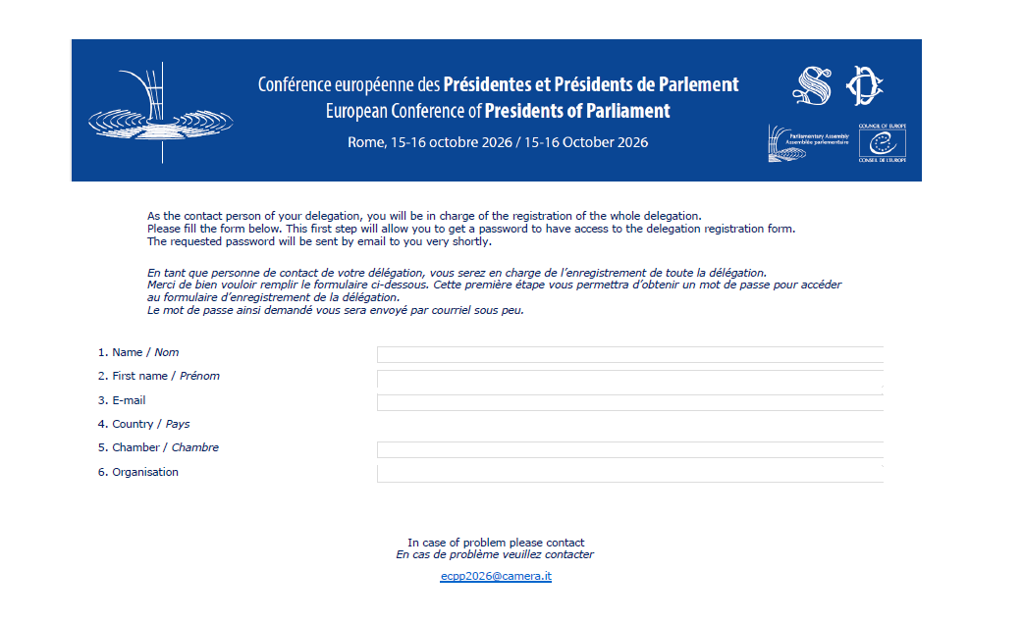

- The online registration of delegations is open until: 22 September 2026.

All participants must be individually registered to access the conference venue (badge) and social events.

Composition of delegations for access to the Conference premises

Access to the Hemicycle will be restricted. In accordance with the rules of the Conference, the size of each delegation is limited to three seats for unicameral Parliaments and six seats for bicameral Parliaments.

An additional seat may be allocated in both cases if the Head of the national delegation to the Parliamentary Assembly of the Council of Europe is included, as would be desirable.

Persons accompanying the delegations (embassy staff, secretariat officials or Members of Parliament of the national delegations) may sit in the Hemicycle, subject to seat availability.

Accommodation

Please find a list of recommended city center hotels in the attached document (list of recommended hotels in appendix). All the hotels are at a close distance from the conference venue. The categories of hotels vary from 3 to 5 stars.

Transportation

No special arrangement regarding arrivals and departures (airport) is foreseen. It is suggested that delegations contact their embassies directly for this purpose.

Security

Please note that each President / Speaker can be accompanied by one security officer (not armed).

Identification badges

Identification badges should be worn at all times during the Conference (meetings, restaurants, social programme, guided tours). Badges will be prepared by the Italian Parliament on the basis of the registration database of participants.

Embassies or secretaries of delegations are encouraged to collect their delegation badges in advance.

Badge pick-up will be available at two points:

1. At the Italian Senate, before the Welcome reception on the eve of the Conference
on Wednesday, 14 October, 10-12; 14.00-18.00
Palazzo Cenci, Piazza S. Eustachio, 83, Rome

At the Italian Senate, before the Working breakfast of Women Presidents of Parliament
on Thursday, 15 October, 8.00-8.30
Palazzo Giustiniani, Via della Dogana Vecchia 29, Rome

2. At the conference venue (Chamber of Deputies)
on Thursday, 15 October, 8.00-17.00
Palazzo Montecitorio, Piazza Montecitorio 1, Rome

Interpretation and documents

Conference documents will be made available in English and French on the PACE website (European Conference of Presidents of Parliament (15 and 16 October 2026, Rome)) and on the Italian Parliament website (ecpp2026.parlamento.it).

Simultaneous interpretation will be provided to and from English, French, German, and Italian.

Additional booths can be allocated, in chronological order of requests made (on a first-come first-served basis), for simultaneous interpretation in other languages. The costs of recruitment of interpreters will be borne by each delegation.

Any delegation requiring interpretation of the speech of their President by their own interpreter will be given access to an interpretation booth. For any request, please contact the Conference Secretariat: ecpp2026@camera.it.

Please note that these requests must comply with the working conditions of interpreters working for the Council of Europe.

List of speakers / Speeches

Presidents (or Vice-Presidents) can already register in the list of speakers (for one or more themes) by contacting the Secretariat of the Conference in Strasbourg: CONFPACE26@coe.int.

The order of speakers on the speakers list will be determined by the drawing of lots organised during the meeting of Secretaries of national delegations (15 October, from 8.30 to 9.30 am). The list thus established will be distributed as soon as possible to allow speakers to know when they will be called to address the Conference.

Speakers registering after the drawing of lots will be added to the list in the order in which they have registered.

In order to facilitate the work of the interpreters, speakers are invited to provide in advance a copy of any written speeches to the Secretariat of the Conference in Strasbourg: CONFPACE26@coe.int.

Bilateral meetings

Meeting rooms will be at the disposal of participants for the purpose of bilateral meetings.

The time slots range from 30 minutes to 1 hour maximum to allow all delegations to have opportunities for bilateral meetings. Delegations are asked to respect the time allocated to allow for room turnover and technical arrangements between meetings.

The meeting rooms can be booked in advance via the online booking system: https://ecpp2026.camera.it/.
To log in, please use the same login details provided to access the registration platform. Requests for assistance can be sent to the following address: ecpp2026@camera.it.

-:-:-:-

Appendix: list of recommended hotels

