Rõue (Kuusiku) river: DS1 DPS3 4+900-5+200
Information in relation to the design and location of the compensatory ponds
Between the two areas proposed for the location of the compensatory ponds at this point (A and B), priority was given to B as it was located on state land, while A was located on private land.

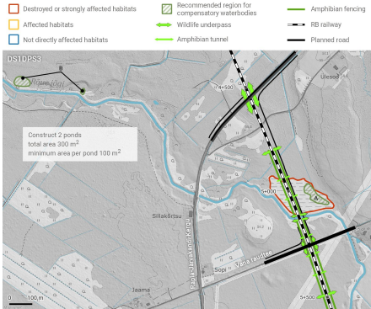
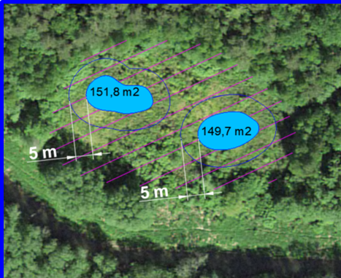

Cadastral reference of the plot where the compensatory ponds will be located: 66904:003:0442
Complete information on the plot according to Maa-amet viewer:
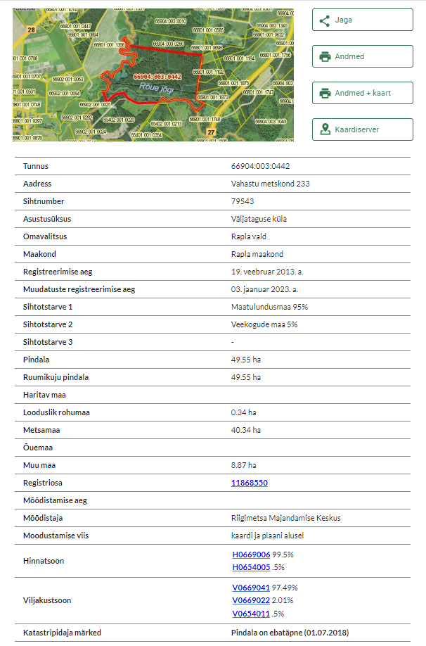
Kaigepere bog: DS1 DPS3 10+000–11+000
Information in relation to the design and location of the compensatory ponds

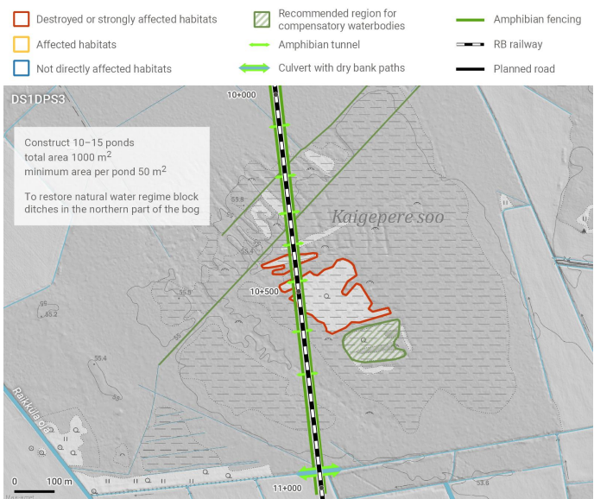
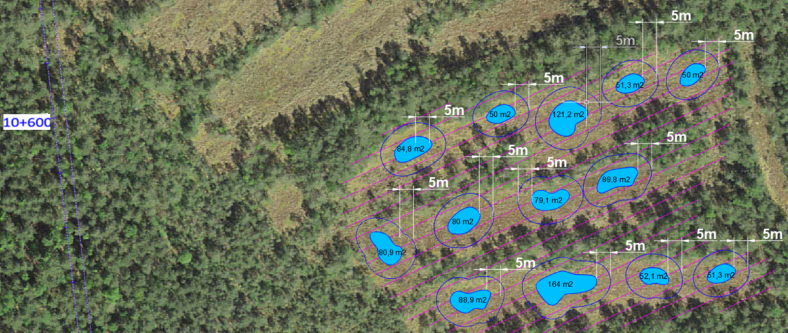

Cadastral reference of the plot where the compensatory ponds will be located: 65402:002:0165

Complete information on the plot according to Maa-amet viewer:
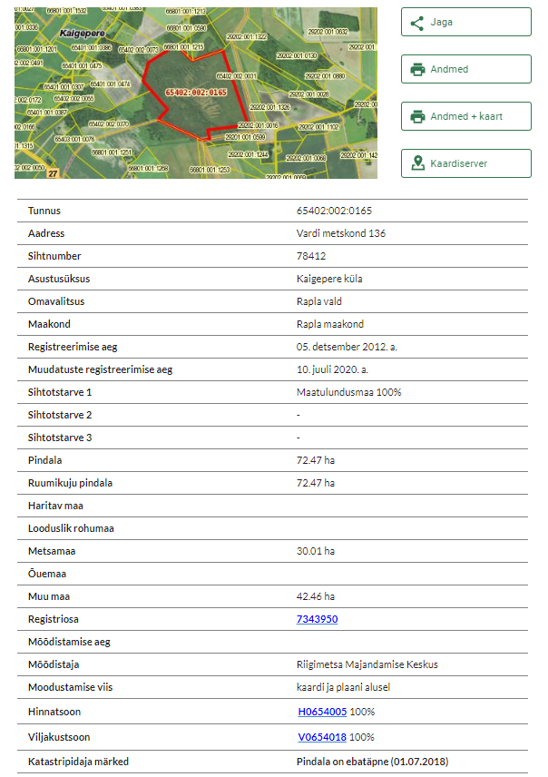

Purku/Lellapere peat pits: DS1 DPS3 13+300–14+000
Information in relation to the design and location of the compensatory ponds
To compensate for the destruction of Pond 1, two locations have been assessed. However, given that zone B is located on state land, it has been selected as the area for the placement of the compensatory ponds.
The rest of the ponds located in this area (2 ,3, 4, 5 and 6) should be preserved
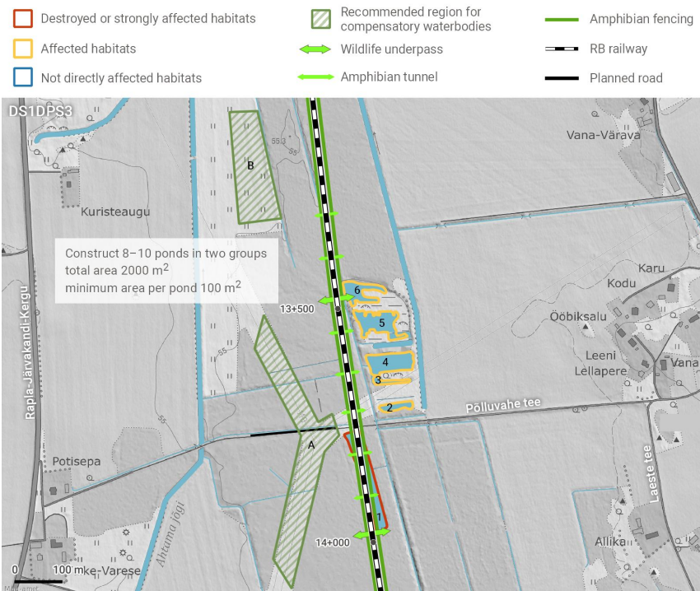
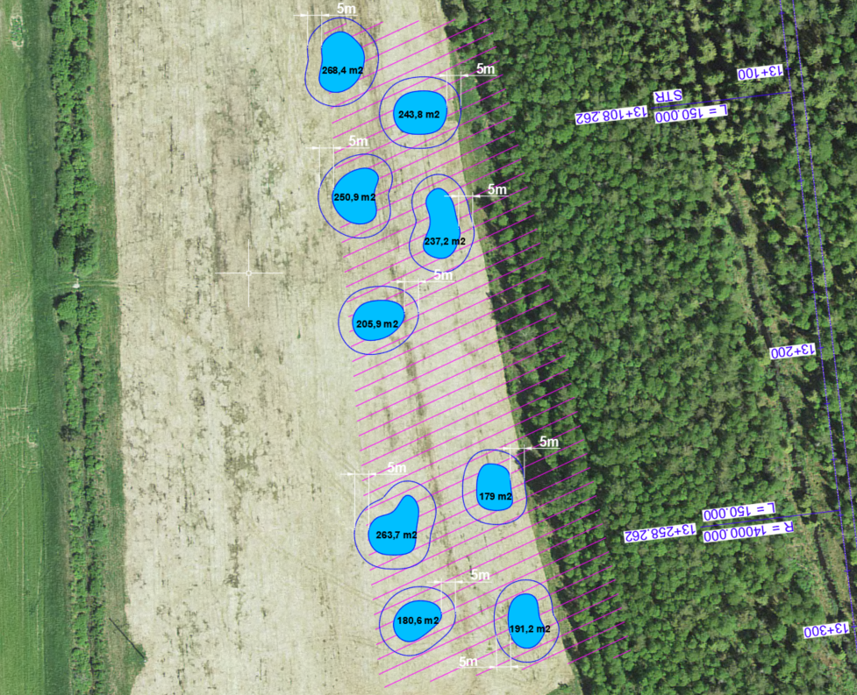

Cadastral reference of the plot where the compensatory ponds will be located: 65403:001:0120
Complete information on the plot according to Maa-amet viewer:
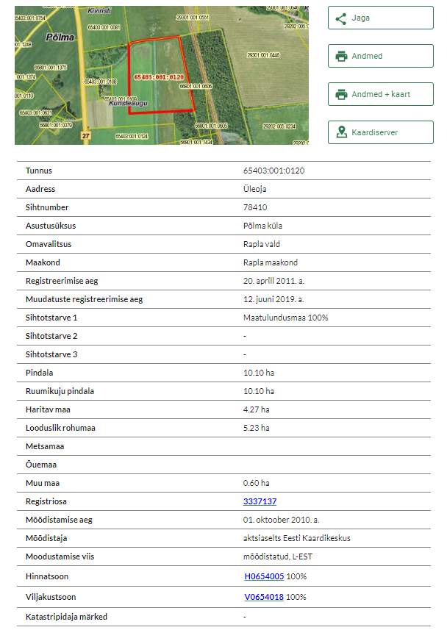
Velise river: DS1 DPS4 3+300–3+700
Information in relation to the design and location of the compensatory ponds
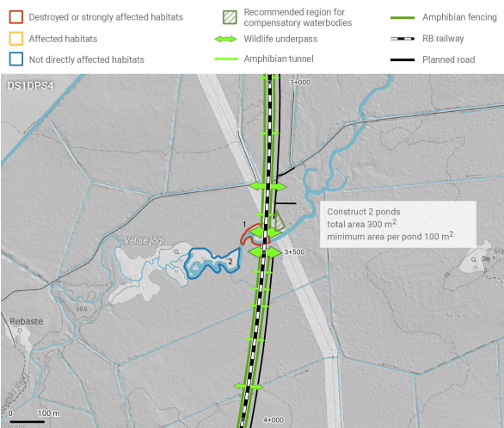
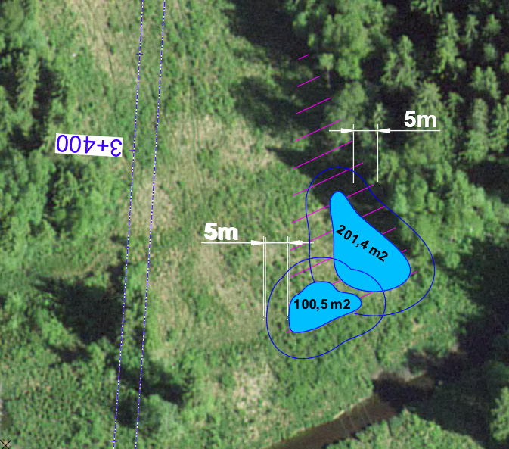

Cadastral reference of the plot where the compensatory ponds will be located: 29202:005:0150
Complete information on the plot according to Maa-amet viewer:
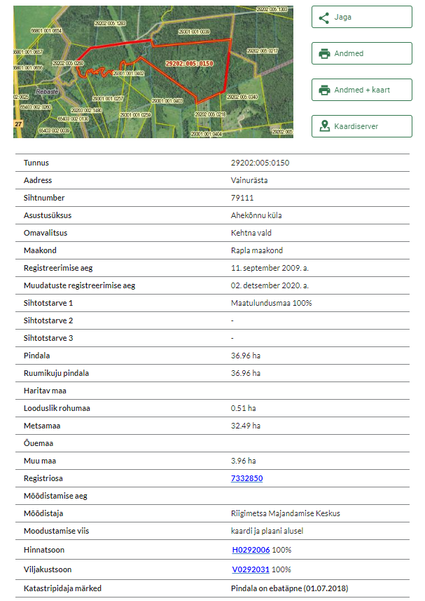

Järvakandi: DS1 DPS4 10+800–11+300

Information in relation to the design and location of the compensatory ponds
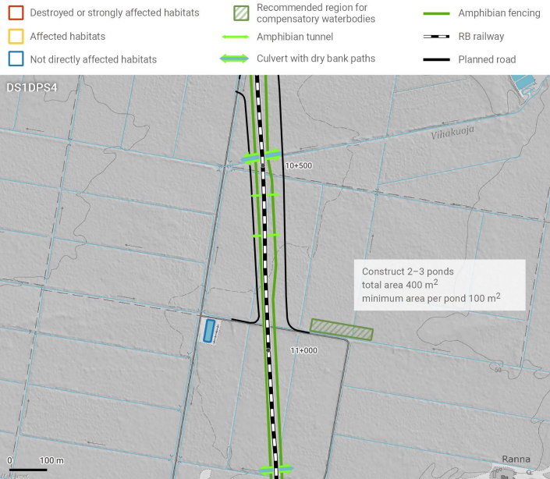
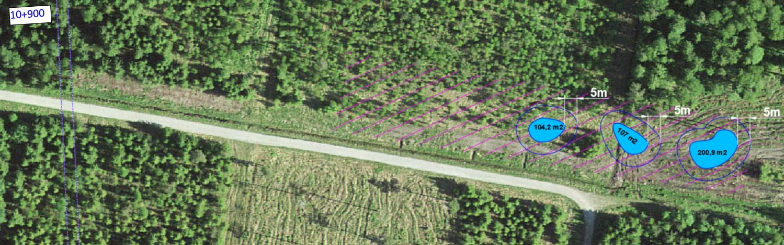

Cadastral reference of the plot where the compensatory ponds will be located: 29203:001:0410

Complete information on the plot according to Maa-amet viewer:
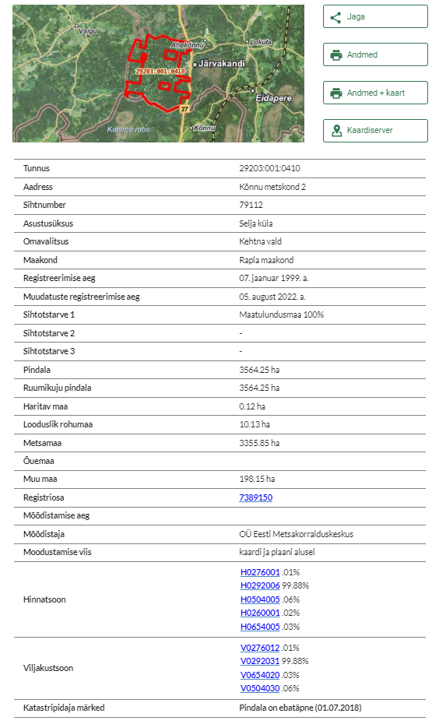
Kõnnu quarry: DS1 DPS5 1+900–2+200

Information in relation to the design and location of the compensatory ponds
To compensate for the destruction of Ponds 1, 2 and 3, three locations have been assessed: A and C in state land and B in private land. 4 ponds have been proposed in zone A, next to the destroyed ones, and other 2 in zone C.
The rest of the ponds located in this area (4, 5 and 6) should be preserved and, if damaged, should be restored as original
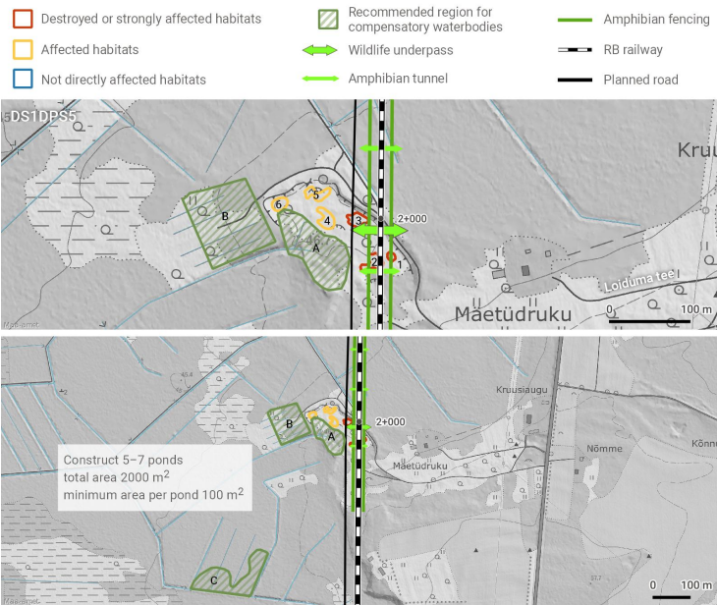
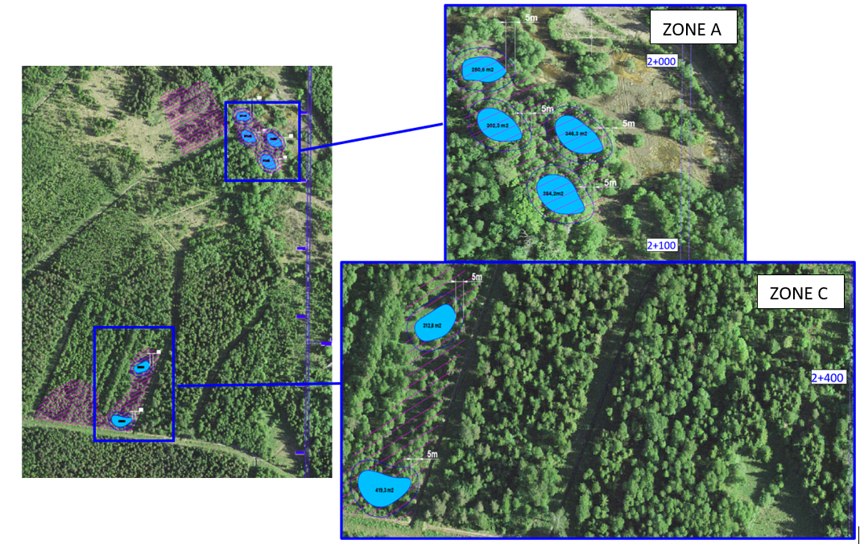

ZONE A
Cadastral reference of the plot where the compensatory ponds will be located: 63801:001:0274
Complete information on the plot according to Maa-amet viewer:
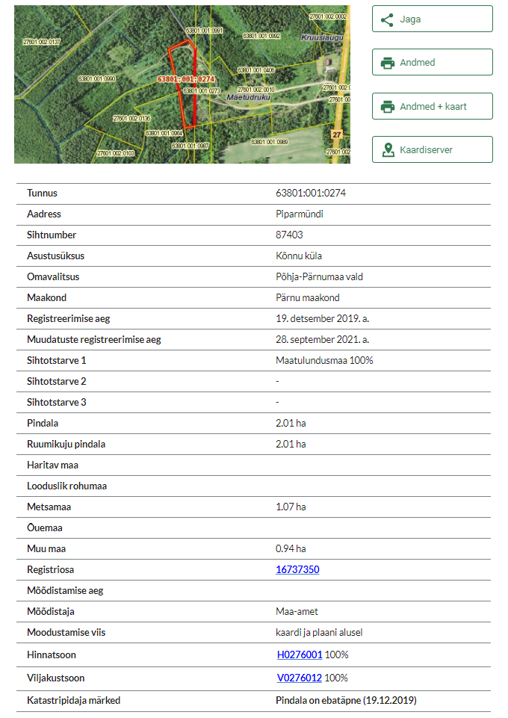
ZONE C
Cadastral reference of the plot where the compensatory ponds will be located: 27601:002:0103
Complete information on the plot according to Maa-amet viewer:
