28 September 2026

Practical Information

Conference date and venue

The Conference will be held on 15 and 16 October 2026 in Rome at:
Chamber of Deputies – Hall of Palazzo Montecitorio
Piazza Montecitorio 1 – 00186 – Rome

In the margins of the Conference:

Wednesday 14 October 2026

- 6.00 to 7.30 pm Welcome reception at Palazzo Sant’Ivo alla Sapienza
(Senate, Corso del Rinascimento 40, Rome)
This event is reserved for Presidents or Vice-Presidents of Parliament and Parliamentary Assemblies + 2 registered persons for each delegation (or Chamber in the case of bicameral parliaments)

Thursday 15 October 2026

- 8.30 to 9.45 am Working breakfast of Women Presidents of Parliament at Palazzo Giustiniani (Senate, Via della Dogana Vecchia 29, Rome)
This event is reserved for Women Presidents or Vice-Presidents of Parliament and Parliamentary Assemblies

- 8.30 to 9.30 am Meeting of Secretaries of national delegations at Palazzo Montecitorio (Chamber of Deputies, Piazza Montecitorio 1, Rome – Sala del Mappamondo)

- 1.15 to 3.00 pm Lunch at Palazzo Montecitorio
(Chamber of Deputies, Piazza Montecitorio 1, Rome)
A sit-down lunch, reserved for Presidents or Vice-Presidents of Parliament and Parliamentary Assemblies + 1 registered person for each delegation (or Chamber in the case of bicameral parliaments) will take place at the Restaurant of deputies (first floor of Palazzo Montecitorio)
A buffet lunch will be set up for the other registered participants in the Sala della Regina (second floor of Palazzo Montecitorio)

- 7.30 pm Visit and dinner reception at the National Museum of Palazzo Venezia
(Via del Plebiscito 118, Rome)
This event is reserved for Presidents or Vice-Presidents of Parliament and Parliamentary Assemblies + 3 registered persons for each delegation

Friday 16 October 2026

- 8.30 to 10.00 am Meeting of Secretaries General of Parliament at Palazzo Montecitorio
(Chamber of Deputies, Piazza Montecitorio 1, Rome – Sala del Mappamondo)

- 12.45 am to 2.45 pm Lunch offered by the President of the Parliamentary Assembly
(La Lanterna, via Tomacelli 157, Rome)
This event is reserved for Presidents and Vice-Presidents of Parliament and Parliamentary Assemblies, Secretaries General and Deputy Secretaries General, as well as Heads of national delegations to the PACE and the parliamentarians accompanying them. They can be joined only by directors, heads of protocol and secretaries of delegations

Please note that no special separate programme has been planned for spouses.

Please also note that in order to access the premises of the Chamber of Deputies, men must wear a jacket, and to access the premises of the Senate, men must wear a jacket and tie.

Website of the conference

Information on the Conference is available on the PACE website (European Conference of Presidents of Parliament (15 and 16 October 2026, Rome)) and on the Italian Parliament website: ecpp2026.parlamento.it.

Contact information Conference secretariat:
Secretariat of the Italian Delegation to PACE
Email address dedicated to the Conference:
eccp2026@camera.it
Phone number: +39 06 6760 3789 -3271

Enrolment procedure – Online registration

- Each delegation should designate a contact person (coordinator) who will be in charge of the registration of the whole delegation. This role should preferably be assumed by the Secretary of the national delegation.

- The designated contact person for each Parliament or House of Parliament can provide their details using the link provided here.

- By entering their email address in the form, the contact person will receive an email containing a link that allows them to register as the contact persons of their delegation and submit their details (see below).

- After this step, the contact person will receive via email a username and password that will enable him/her to access the delegation’s registration forms website.

- The forms access page also provides instructions for filling in the forms.
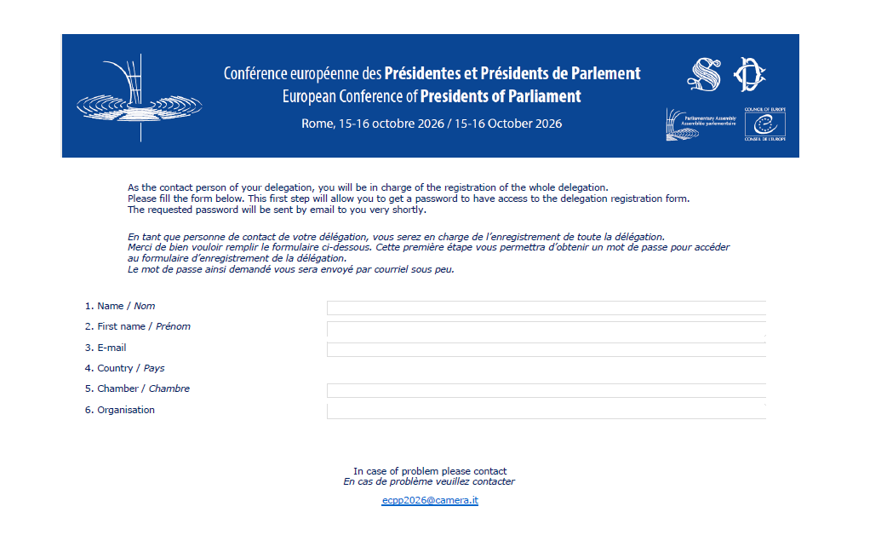

- The online registration of delegations is open until: 22 September 2026.

All participants must be individually registered to access the conference venue (badge) and social events.

Composition of delegations for access to the Conference premises

Access to the Hemicycle will be restricted. In accordance with the rules of the Conference, the size of each delegation is limited to three seats for unicameral parliaments and six seats for bicameral parliaments.

An additional seat may be allocated in both cases if the Head of the national delegation to the Parliamentary Assembly of the Council of Europe is included in the delegation, as would be desirable.

The seating plan for national delegations in the Hemicycle will be accessible via the QR code on the back of the badge.

Persons accompanying the delegations (embassy staff, secretariat officials or Members of Parliament of the national delegations) may sit in the Hemicycle, subject to seat availability, in a designated area for guests.

Transportation

No special arrangement regarding arrivals and departures (airport) is foreseen. Delegations are invited to contact their embassies for this purpose.

Delegations wishing to request access to Piazza Montecitorio by car are invited to contact the Protocol Office of the Chamber of Deputies at cerimoniale@camera.it.

Security

Please note that each President / Speaker can be accompanied by one security officer (not armed).

Security officers will be permitted to enter the Parliament buildings, provided that they are unarmed (it will not be possible for them to leave their arm at the entrance). However, they will not be permitted to enter the Chamber, the meeting rooms or the rooms where social events are held (lunch on 15 October). For the welcome reception at Palazzo Sant’Ivo on the evening of 14 October, the dinner reception at Palazzo Venezia on the evening of 15 October, and the lunch at La Lanterna on 16 October, security officers will be required to remain outside the premises.

Identification badges

Identification badges should be worn at all times during the Conference (meetings, restaurants, social programme, guided tours). Badges will be prepared by the Italian Parliament on the basis of the registration database of participants according to the following categories:

- RED President or Vice-President of Parliament
- BORDEAUX MP, Head of national delegation to the PACE
- YELLOW Secretary General or Deputy Secretary General
- LIGHT BLUE Staff and Secretariats of national delegations (including Parliamentary Officials)
- DARK BLUE Staff of PACE and Conference Secretariat
- GREEN Embassy
- GREY Interpreter
- ORANGE Press
- BLACK with a stripe Security
- TURQUOISE Liaison Officers
- PURPLE Other categories

Floating badges will be provided for embassies and security officers to allow entrance for a limited number of registered persons (to be defined).

Embassies or secretaries of delegations are invited to collect their delegation badges in advance. Only registered contact persons or registered embassy staff can collect badges.

Badge pick-up will be available at three points:

1. At the Italian Senate, before the Welcome reception on the eve of the Conference
on Wednesday, 14 October, 10.00 am- 6.00 pm
Palazzo Cenci, Piazza S. Eustachio, 83, Rome
To enter the building, men must wear a jacket and tie

2. At the Italian Senate, before the Working breakfast of Women Presidents of Parliament
on Thursday, 15 October, 8.00-8.30 am
Palazzo Giustiniani, Via della Dogana Vecchia 29, Rome
To enter the building, men must wear a jacket and tie

3. At the conference venue (Chamber of Deputies)
on Thursday, 15 October, 8.00 am -5.00 pm
Palazzo Montecitorio, Piazza Montecitorio 1, Rome
To enter the building, men must wear a jacket

Interpretation and documents

Conference documents will be made available in English and French on the PACE website (European Conference of Presidents of Parliament (15 and 16 October 2026, Rome) and on the Italian Parliament website (ecpp2026.parlamento.it).

Simultaneous interpretation will be provided to and from English, French, German, and Italian.

Additional booths can be allocated, in chronological order of requests made (on a first-come first-served basis), for simultaneous interpretation in other languages. The costs of recruitment of interpreters will be borne by each delegation.

Any delegation requiring interpretation of the speech of their President by their own interpreter will be given access to an interpretation booth. For any request, please contact the Conference Secretariat: ecpp2026@camera.it.

Please note that these requests must comply with the working conditions of interpreters working for the Council of Europe.

Duly registered interpreters will be permitted to access all conference venues, including the social events, where their presence is required by the head of their delegation. However, during seated dinners and lunches they shall not take a seat at the table, but can be provided with a chair in order to sit behind the President or Vice-President.

List of speakers / Speeches

Presidents (or Vice-Presidents) can already register in the list of speakers (for one or more themes) by contacting the Secretariat of the Conference in Strasbourg: CONFPACE26@coe.int.

The order of speakers on the speakers list will be determined by the drawing of lots organised during the meeting of Secretaries of national delegations (15 October, from 8.30 to 9.30 am). The list thus established will be distributed as soon as possible to allow speakers to know when they will be called to address the Conference.

Speakers registering after the drawing of lots will be added to the list in the order in which they have registered.

In order to facilitate the work of the interpreters, speakers are invited to provide in advance a copy of their speeches to the Secretariat of the Conference in Strasbourg: CONFPACE26@coe.int.

Bilateral meetings

Meeting rooms will be at the disposal of participants for the purpose of bilateral meetings.

Delegations will be able to book different time slots for a duration of 30 minutes each. Should a delegation need more than 30 minutes for a meeting, they will need to book 2 consecutive slots in order to have 60 minutes available. Please make sure that this request is sent by one delegation per meeting only in order to avoid any overlapping: once the slot(s) has/have been booked, both delegations participating in the bilateral meeting will receive a confirmation message.

A dedicated room will be available for bilateral meetings with Ukraine. Bilateral meetings with Presidents Bayr, La Russa and Fontana will take place in their respective dedicated rooms and do not need to be booked through the system; please arrange these meetings directly with their respective points of contact.

To allow all delegations to have opportunities for bilateral meetings, delegations are asked to respect the time allocated to allow for room turnover and technical arrangements between meetings.

The meeting rooms can be booked in advance via the online booking system: https://ecpp2026.camera.it/.
To log in, please use the same login details provided to access the registration platform. Requests for
assistance can be sent to the following address: ecpp2026@camera.it.

Press and photos
Registered press accompanying the delegations will have to access Montecitorio at Via della Missione n.4 before 9.30 am on 15 October.
Galleries D and E of the Hemicycle will be reserved for camera operators and photographers (both galleries are provided with audio output), while Gallery F will be reserved for journalists.
An interview area will be set up in the Presidents’ Gallery on the first floor of Montecitorio. A press room will be set up in the Sala Rossa, accessible from the same gallery. Video recording and photography are not permitted outside this room. Accredited journalists and camera crews will be escorted there by conference staff.
The Italian parliament will provide photographic coverage of the Conference sessions, the Women Presidents’ Breakfast and the family photos. All the images will be available on the ECPP website (ecpp2026.parlamento.it) in the ‘Photo and Video gallery’ section.

The Italian Parliament will not be responsible for providing photographic coverage of bilateral meetings. Delegations may accredit their own photographers for this purpose.

For any additional information, please contact sg_ufficiostampa@camera.it or 0667609033.

Live streaming

The Conference will be streamed live on the Chamber of Deputies web TV and on the website of the PACE Conference (original language and interpretation into Italian, English, French, and German).

