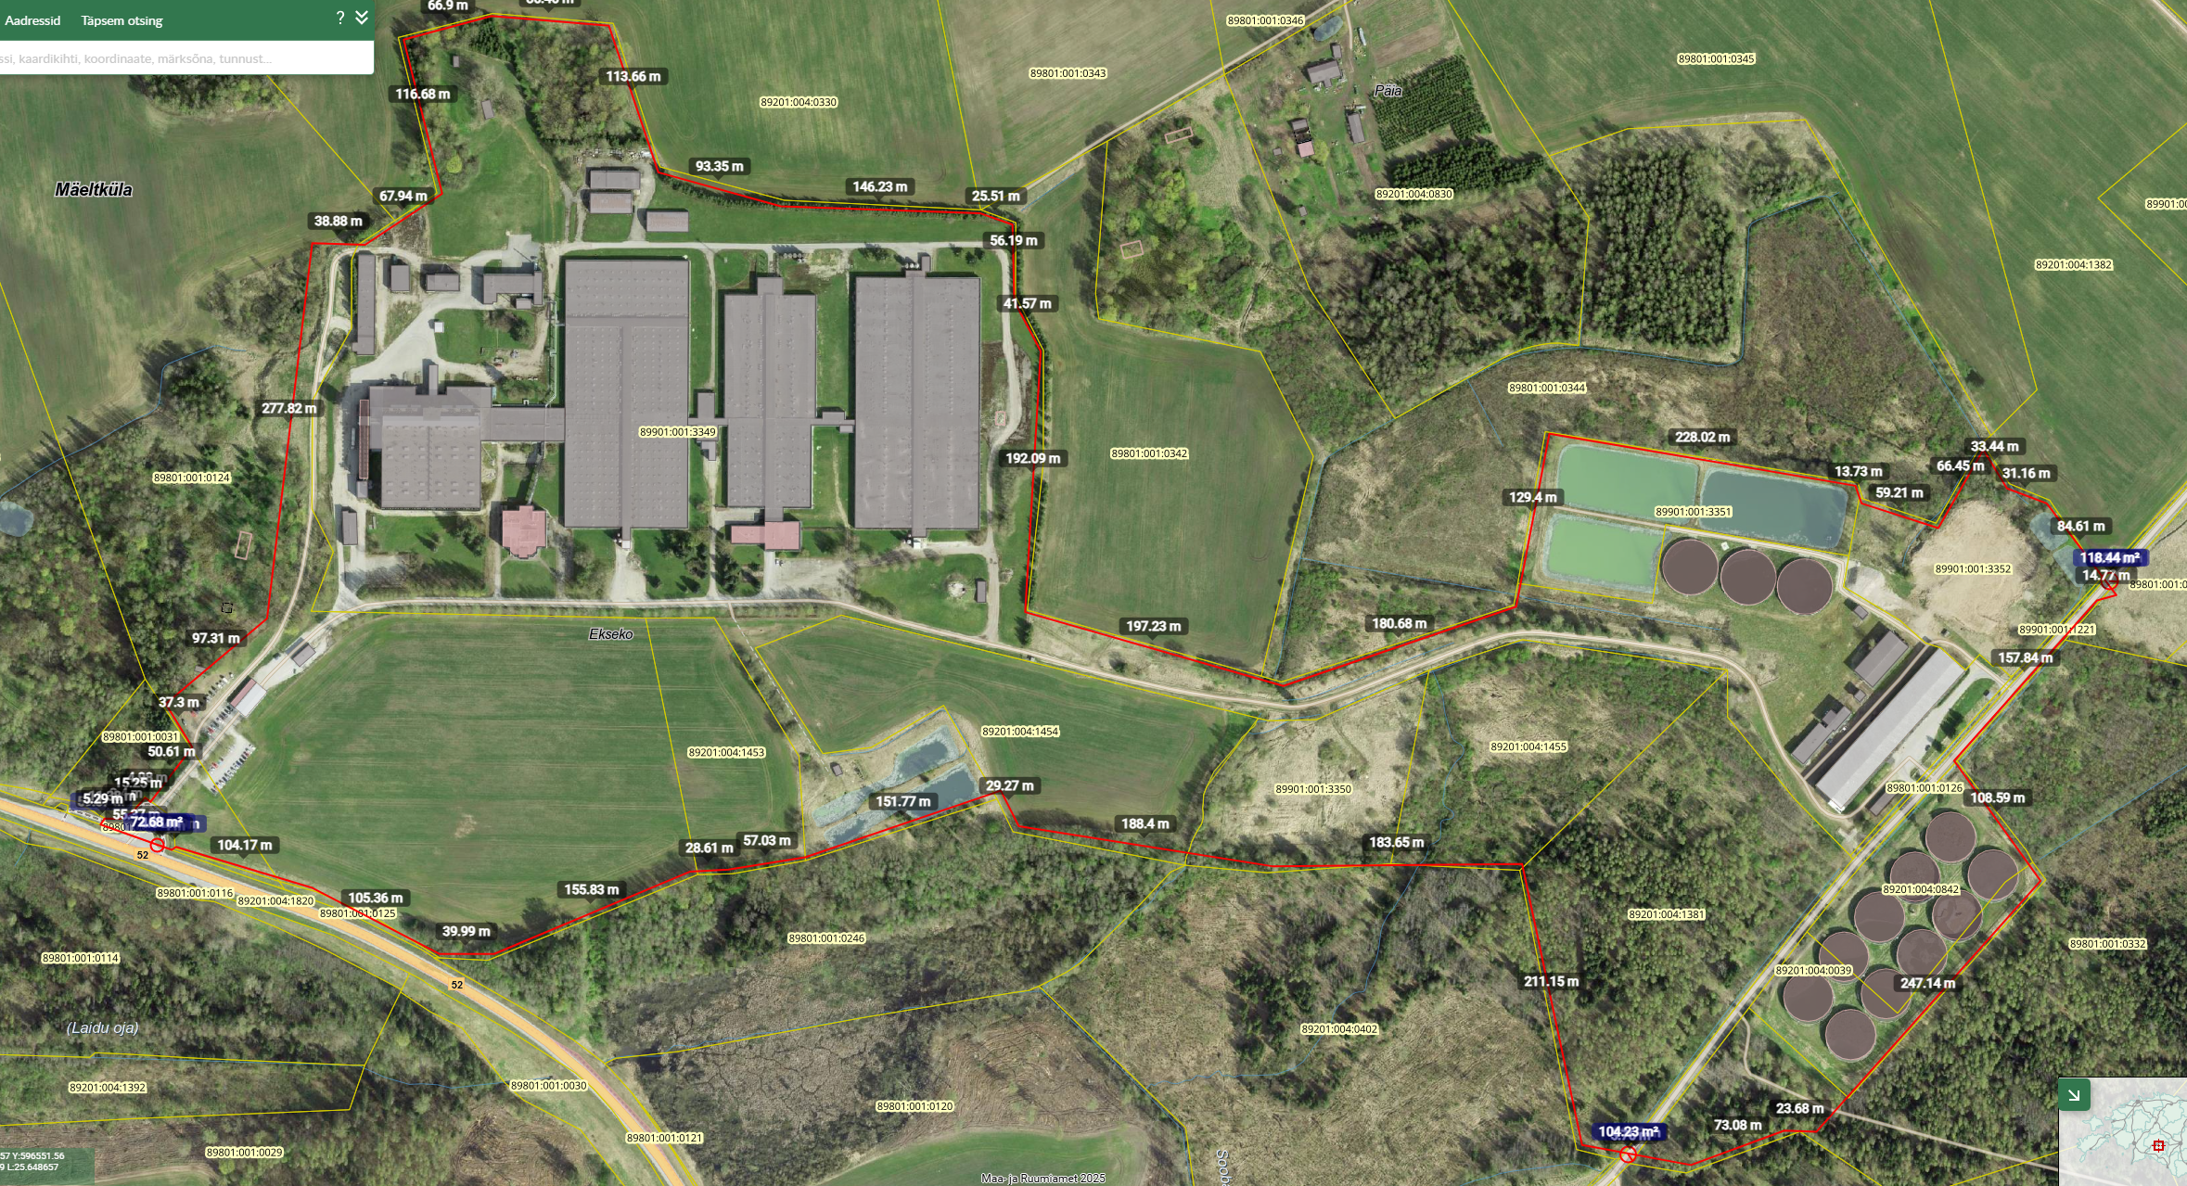
Leitav ka: https://xgis.maaamet.ee/xgis2/page/link/BCXZvKfP

