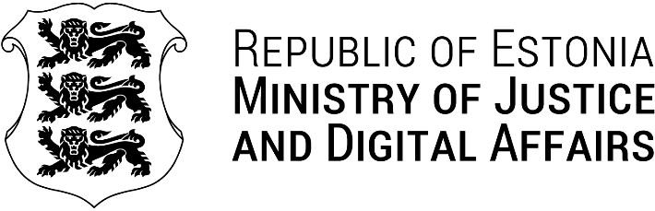
Our Ref: 11.06.2025 | No 7-2/5055
Mr. Rimantas Mockus
The Ministry of Justice of the Republic of Lithuania
rimantas.mockus@tm.lt
Gedimino ave. 30, LT-01104 Vilnius

Dear Minister,

At first allow me to express my sincere congratulations and best wishes on your recent appointment as the Minister of Justice of the Republic of Lithuania.

In the spirit of enhancing cooperation between our countries in the fields of justice and imprisonment, i and my team would be delighted to introduce our prison system as well as our latest developments in this field.

Therefore, I am pleased to invite you and your delegation to a visit in Estonia from the 25th to the 27th of February 2025. As part of the visit, I would be honored if you could join me for a lunch on the 25th of February.

If you have any further questions, please do not hesitate to contact Ms. Kristin Kaur by e-mail: Kristin.kaur@justdigi.ee .

I am looking forward to continue and to intensify the co-operation between our countires.

Please accept the assurances of my highest consideration.

Yours sincerely,

Liisa-Ly Pakosta

Minister of Justice and Digital Affairs of Estonia

