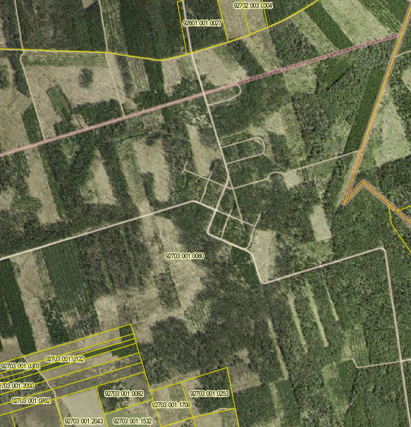
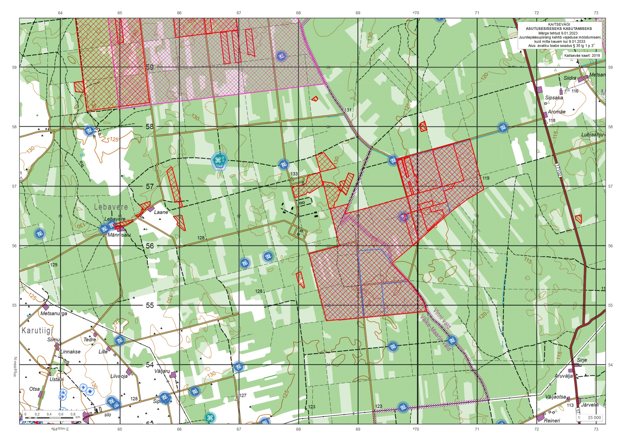
StSiKo kooskõlastus Rohu+Kadila Lisa 1
Rohu raketibaas
Katastri tunnus: 92703:001:0080
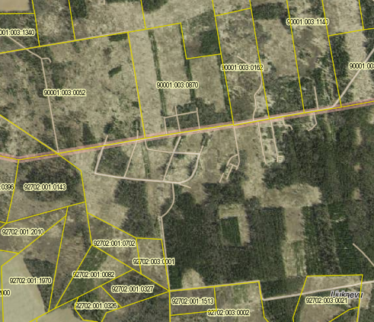
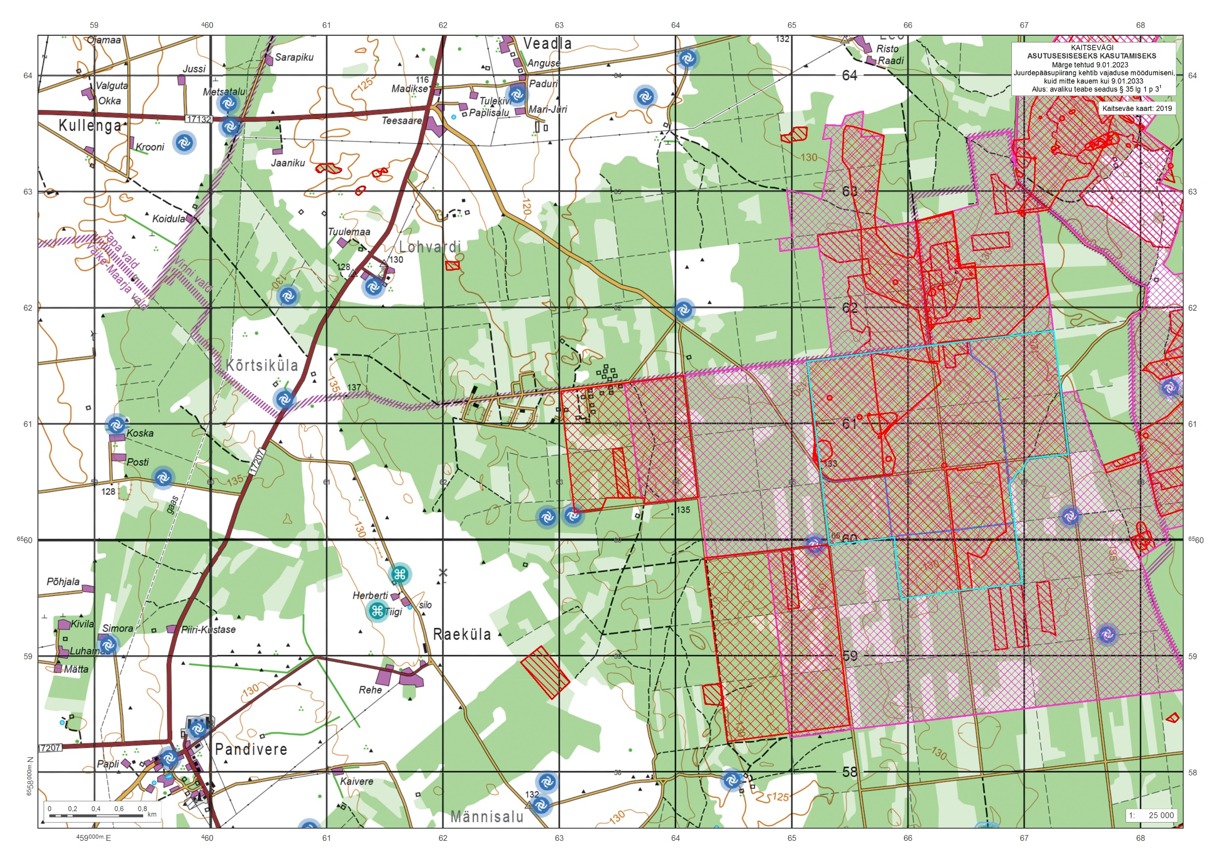
Kadila raketibaas
Katastri tunnus:
92702:003:0210
92702:003:0001
92702:001:0702
92702:001:0327
92702:001:0082
92702:001:0842
92702:001:0143
90001:003:0052
90001:003:0870
90001:003:0162
90001:003:1161
90001:003:1140

