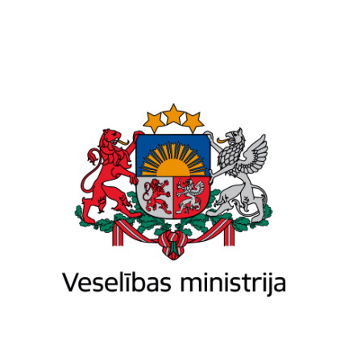

Ministry of Health of the Republic of Latvia

Brīvības iela 72 k-1, Rīga, LV-1011, tālr. 67876000, fakss 67876002, e-pasts pasts@vm.gov.lv, www.vm.gov.lv
Riga

25.03.2024Nr. 01-19.1/1193

Ms Riina Sikkut,
Minister of Health
of the Republic of Estonia,
Mr Arūnas Dulkys,
Minister of Health
of the Republic of Lithuania
Dear ministers,

I wish to sincerely thank your experts and you personally for finding the time to actively participate in the Baltic Policy Dialogue in Riga. I believe we had very fruitful discussions that will significantly further the primary health care reform agenda in all the Baltic States.

Moreover, I am very pleased to have had the opportunity to hold a trilateral meeting with you within the margins of the Dialogue. We all agreed that unfortunately, the world and our region especially are going through very unstable times, and it is our duty as health ministers to ensure better preparedness of the health sector for crisis situations. In this regard, I am pleased to note that we were in accord that concrete practical steps need to be taken to review and optimize processes related to manufacturing, procurement, logistics and stockpiling of critical medicines.

One very concrete practical step we agreed upon is the establishment of a joint Baltic high-level working group to further enhance cooperation amongst our States. I stated during our meeting – and I stand by my words – that closer cooperation in the critical medicines area would equally benefit all our countries.

In this regard, I hereby inform you that I have nominated State Secretary of the Ministry of Health, Ms Agnese Vaļuliene, as Latvia’s representative to the working group, while Ms Elīza Bērziņa, Director of the Department European Affairs and International Cooperation at the Ministry of Health, will serve as the coordinator for the working group.

I kindly ask that you nominate relevant high-level representatives to the working group by sending this information to the e-mail address es@vm.gov.lv. My vision is to proceed without hesitation once we receive the nominations and to organize an online call to agree on the next steps.

I truly look forward to our work together on this very critical issue.

Yours sincerely,

Minister of Health | (signature*) | Hosams Abu Meri

Elīza Bērziņa 67876081
eliza.berzina@vm.gov.lv

