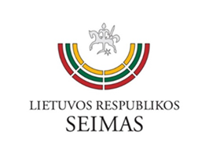
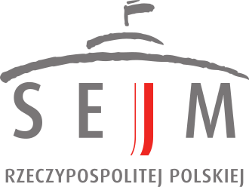
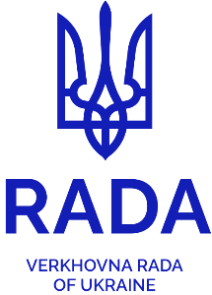


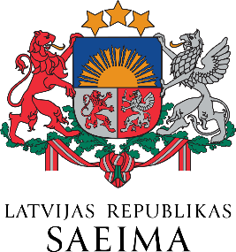
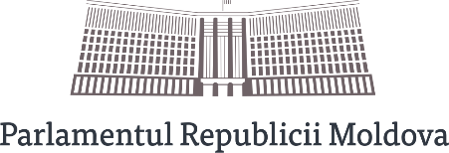

DECLARATION
OF A MEETING OF DELEGATIONS OF PARLIAMENTARY COMMITTEES ON AGRICULTURE OF THE LUBLIN TRIANGLE (LITHUANIA, POLAND, UKRAINE)
WITH THE PARTICIPATION OF REPRESENTATIVES FROM THE PARLIAMENTS OF ESTONIA, LATVIA AND MOLDOVA

20 March 2026
Vilnius
We, the undersigned Members of the Committees on Agriculture of the Seimas of the Republic of Lithuania, the Sejm of the Republic of Poland, the Verkhovna Rada of Ukraine, the Riigikogu of the Republic of Estonia, the Saeima of the Republic of Latvia and the Parliament of the Republic of Moldova,
meeting on 20 March 2026 at the Seimas of the Republic of Lithuania in Vilnius,
stressing the strategic importance of the agri-food sector for Europe’s security, economic resilience, and vibrant rural areas,
having regard to the discussions on the post-2027 Common Agricultural Policy, the integration of Ukraine and Moldova into the European Union, and fair competition in the food supply chain,
hereby declare:

- Regarding the post-2027 Common Agricultural Policy
1. We hereby emphasise that the Common Agricultural Policy (hereinafter: CAP) is one of the European Union’s key policies ensuring food security, the stability of incomes of farmers and agricultural businesses, and functioning of rural areas, in accordance with the provisions of the EU Treaties.
Proposed new compromise wording:
2. We emphasise that the CAP must remain a visible, clearly defined, and adequately funded policy that ensures food security, the long-term competitiveness of the agricultural sector. The CAP must remain financially distinct and should not compete for funding with other sectors.
3. We note that the opinion of the European Court of Auditors on the MFF for 2028–2034 and the CAP reform indicates that the proposed integration of the CAP into a common fund, although presented as a simplification, may in fact increase the risk of undermining the CAP as a common European policy.
4. We underline the need to complete the process of external convergence of direct payments and to ensure a level playing field in the single market for farmers from all Member States.
Proposed new compromise wording:
5. In view of geopolitical instability and food security challenges, we call for maintaining the stability of the Common Agricultural Policy (CAP), particularly in the context of inflationary pressures and increasing fiscal burdens, ensuring that climate transition measures are accompanied by adequate support mechanisms for farmers, particularly in the EU's eastern border region. The financing for the 2028–2034 period must ensure the continuity of production capacities and provide conditions that realistically reflect the additional responsibilities placed on the EU agricultural sector in relation to security, resilience, and food supply.
Proposed new compromise wording:
6. In the context of Russia’s war against Ukraine and other conflicts continuing worldwide, when the agricultural sector faces exceptional economic pressure, particularly rising production costs, we call on the European Commission to suspend the application of additional charges, including those related to CO₂ emissions on the agricultural sector and to provide measures to compensate farmers for the rise in fuel and fertiliser costs.
Proposed new compromise wording:
7. We call for the new CAP to strengthen the strategic autonomy of Europe in terms of food security by strengthening production capacity and reducing dependence on imports, particularly in the eastern border region of the EU. We request a review of the rules for signing international agreements, including the EU-MERCOSUR trade agreement and other agreements that pose threats to the safety of European farmers and consumers.
8. In the context of the CAP, we call for maintaining a clear priority for rural development and vibrant rural areas, with appropriate legal anchoring and well-targeted, sufficient funding.

II. Regarding the integration of Ukraine and Moldova into the European Union
Proposed new compromise wording:
1. We strongly condemn the Russian Federation’s aggression against Ukraine, which has now continued for five years, and reaffirm our unwavering support for Ukraine’s independence, sovereignty and territorial integrity within its internationally recognised 1991 borders. We underline that the integration of Ukraine and Moldova into the European Union is not only a political and economic process, but also an essential factor in strengthening European economic security and stability, by expanding the European manufacturing sector and increasing export and logistics capacity.
Proposed new compromise wording:
2. We congratulate Ukraine and Moldova on their candidate status for accession to the European Union and the opening of accession negotiations with them. We call on the EU to ensure a credible, predictable, and merit-based enlargement process, taking into account the concerns and interests of European farmers, particularly those from the neighbouring countries where agriculture accounts for a significant share of the economy. We also call on the EU to ensure a fair enlargement process that will provide adequate support for the implementation of regulations (standards) that impose an economic burden on candidate countries, in a manner mirroring the support provided to EU member states when implementing similar regulations, or by extending the deadlines for the entry into force of such regulations.
Proposed new compromise wording:
3. We express our strong support for the swift accession of Ukraine and Moldova as full members of the European Union. We support the efforts of the EU institutions and the Member States to ensure that these negotiations proceed at the technical level. We call on the EU institutions and the Member States to provide a clear pathway for Ukraine and Moldova to become full members of the European Union as swiftly as possible, in line with merit-based progress.
Proposed new compromise wording:
4. We emphasise the need to promote cooperation between market participants in the European Union Member States and candidate countries.
Proposed new compromise wording:
5. At the same time, we stress that the integration must be a gradual process, supported by clear and transparent planning, and comprising transitional measures and periods. The integration of the agri-food sector into the single market must take place in a way that guarantees a level playing field for all market participants in terms of production standards, including the sustainable use of plant protection products, food safety, plant health, the environment and animal welfare, whilst ensuring the continued stability of the internal market

We call for:
Proposed new compromise wording:
- providing additional, financial instruments for preparing the agricultural sectors of Ukraine and Moldova for accession, ensuring that this funding is backed up by additional EU resources, and does not affect the budget or the support provided to farmers in the current Member States under the CAP;
Proposed new compromise wording:
- strengthening administrative capacity, the development and implementation of legislation, and the building of supervisory and control systems; as well as introducing uniform conditions and standards for agricultural production;
- preventing integration from imposing a disproportionate competitive or financial burden on farmers in countries that are already EU Member States;
Proposed new compromise wording:
- applying, where necessary, the transitional periods, including those relating to the access of agricultural products from Ukraine and Moldova to the single market, protective mechanisms for sectors facing economic difficulties, and the possibility of providing adequate compensation
III. Final provisions
1. We reaffirm our determination to strengthen parliamentary cooperation in the field of agricultural and food policy within the Lublin Triangle and in a wider regional format.
2. We encourage the agricultural and rural affairs committees of the parliaments of the EU Member States to strengthen interparliamentary dialogue and cooperation with a view to coordinating positions and shaping a common EU-level approach to the future of the Common Agricultural Policy, the competitiveness of farmers, and the strengthening of European food security.

Bronis Ropė
Chair of the Committee on Rural Affairs
Seimas of the Republic of Lithuania

Mirosław Maliszewski
Chair of the Committee on Agriculture and Rural Development
Sejm of the Republic of Poland

Oleksandr Gaydu
Chair of the Committee on Agrarian and Land Policy
Verkhovna Rada of Ukraine

Maido Ruusmann
Member of the Rural Affairs Committee
Riigikogu of the Republic of Estonia

Jana Simanovska
Chair of the Environmental, Climate and Energy Subcommittee of the
Economic, Agricultural, Environmental and Regional Policy Committee
Saeima of the Republic of Latvia

Serghei Ivanov
Chairperson of the Committee on Agriculture and Food Industry
Parliament of the Republic of Moldova

