

O/Ref: AK-CFA-2026-1001

Sèvres, 13 January 2026

Embassies in Paris of the States Parties to the Metre Convention
The President of the Académie des sciences (France) Members of the CIPM

Convocation of the 28th meeting of the
General Conference on Weights and Measures (CGPM)

Pursuant to Article 7 of the Regulations annexed to the Metre Convention, we are writing to inform you that the International Committee for Weights and Measures (CIPM) has decided to convene the 28th meeting of the General Conference on Weights and Measures (CGPM) from Tuesday 13 to Thursday 15 October 2026 at the Palais des Congrès de Versailles, 10 rue de la Chancellerie, 78000 Versailles, Yvelines, France.

Pursuant to Article 4 of the Convention, the CGPM will be chaired by Prof. Françoise Combes, the current President of the Académie des sciences (France).

The meeting will be held in a hybrid format allowing both in-person and remote participation. To support this, the CIPM is proposing that the CGPM adopt a Special Procedure at its 28th meeting to regulate its conduct in this respect. The Special Procedure is attached to this letter. It will be considered during the opening session of the meeting. We would be grateful if States Parties could indicate their support for the adoption of the proposed Special Procedure to the CIPM Secretary by 31 May 2026.

A list of the draft resolutions proposed by the CIPM for discussion at the 28th meeting of the CGPM together with a draft agenda are attached to this letter.

With a view to ensuring distribution of materials to all States Parties within the four (4) month time limit agreed in Resolution 10 adopted by the CGPM at its 9th meeting (1948), States Parties are invited to present their proposals through diplomatic channels by 31 May 2026.

States Parties are asked to present the composition and credentials for their delegations to the Director of the BIPM by Monday 28 September 2026.

We kindly request that all communications concerning the 28th meeting of the CGPM be addressed by email to cgpm@bipm.org.

We will be organizing three on-line briefing sessions to keep participants informed about the plans for the meeting. The CIPM President will also use these sessions as an opportunity to propose plans to convene an informal dotation committee for the CGPM. Information about these sessions will be communicated in due course.

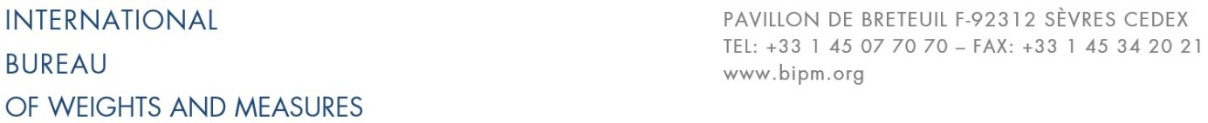
The detailed programme for the meeting and other relevant documentation will be available from the BIPM website, which will be updated regularly during the preparation of the meeting: https://www.bipm.org/en/cgpm-2026.

For the International Committee for Weights and Measures

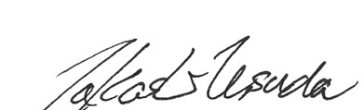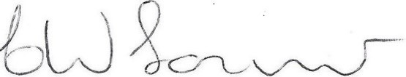

CIPM Secretary CIPM President
Dr Takashi Usuda Dr Wynand Louw

Annex 1 List of Draft Resolutions for the 28th meeting of the CGPM

Annex 2 Provisional agenda for the 28th meeting of the CGPM

Appendix Special Procedure to regulate the conduct of the 28th meeting of the CGPM

CC

Directors of National Metrology Institutes of States Parties to the Metre Convention

Annex 1

List of Draft Resolutions for the 28th meeting of the General Conference on Weights and Measures

- On universal adherence to the Metre Convention

- On the future definition of the second

- On the technical actions needed to ensure the continuity of UTC

- On the definition of an international lunar reference time scale and its traceability to UTC

- On the further digital transformation of the global metrology system

- On the adoption of Rules of Procedure of the General Conference on Weights and Measures
V. On the dotation of the International Bureau of Weights and Measures for the years 2028 to 2031

The Draft Resolutions are available from the website at:
https://www.bipm.org/en/cgpm-2026.

Annex 2

Provisional agenda for the 28th meeting of the General Conference on Weights and Measures

Presentation of credentials by Delegates

- Opening of the meeting
- Address by His Excellency the Ministre de l’Europe et des Affaires Étrangères de la République française
- Reply by the President of the CIPM
- Address by the President of the Académie des sciences (France), President of the General Conference
- Nomination of the Secretary of the General Conference
- Establishment of the list of Delegates entitled to vote
- Approval of the agenda
- Special Procedure to regulate the conduct of the 28th meeting of the CGPM
- Report of the President of the CIPM on the work accomplished since the 27th meeting of the CGPM
- Report of the Director of the BIPM on the work accomplished since the 27th meeting of the CGPM

The order and timings proposed for the following agenda items will be indicated on the detailed timetable.

- Presentations by representatives of intergovernmental organizations and international bodies
- Report on relations with intergovernmental organizations and international bodies
- Reports by Presidents of the Consultative Committees
- On universal adherence to the Metre Convention (Draft Resolution A)
- On the future definition of the second (Draft Resolution B)
- On the technical actions needed to ensure the continuity of UTC (Draft Resolution C)
- On the definition of an international lunar reference time scale and its traceability to UTC (Draft Resolution D)
- On the further digital transformation of the global metrology system (Draft Resolution E)
- On the adoption of Rules of Procedure of the General Conference on Weights and Measures (Draft Resolution F)
- Report from the Chair of the CIPM Sub-Committee on Finance
- The proposed Work Programme of the BIPM for 2028-2031
- Nomination of members for a Working Group on the Dotation of the BIPM
- On the dotation of the International Bureau of Weights and Measures for the years 2028 to
2031 (Draft Resolution V)
- Proposals by Delegates
- Votes on all Resolutions
- Election of the CIPM
- Election of the Committee for CIPM Election (CEC)
- Other business
- Closure of the meeting

