 | EUROPEAN COMMISSION  DIRECTORATE-GENERAL FOR EDUCATION, YOUTH, SPORT AND CULTURE  Directorate R - Resources  Unit R3 – Accounting and finance
Methodology for assessing the financial capacity
of the beneficiaries of grants
One of the tasks of the Directorate-General for Education, Youth, Sport and Culture (DG EAC) is to provide a direct financial contribution, in the form of grants, to projects or organisations which support the interests of the European Union or which participate in the implementation of an EU programme or policy in the field of culture, youth, sport and education. In general, the parties interested in receiving grants reply to public calls for proposals.
The grant applications submitted by the interested parties are subject among other things to an assessment based on the selection criteria, including verification of the applicants' financial capacity.
In order to ensure the assessment of financial capacity, DG EAC has set up a methodology in line with Articles 197(1)(b), 199 and 201 of the Financial Regulation (FR).
This methodology describes the scope, the documents requested from the beneficiaries and, where an actual analysis is performed, the financial ratios used and the interpretation of the results obtained.
The preparation of the of the financial capacity assessment is delegated by DG EAC to the Central Validation Service, hosted in the European Research Executive Agency.
- Scope
Assessment of financial capacity as a selection criterion applies to all grants.
Under Article 199 of the Financial Regulation, and based on a risk analysis, the authorising officer is not required to request proof of financial capacity for grants worth EUR 60 000 or less.
Taking account of the specific nature of the grants administered by DG EAC, the decision was taken to perform a financial capacity analysis when the value of the pre-financing exceeds EUR 600 000. For values above this threshold, proof of financial capacity will be required on a case-by-case basis according to the hypothetical cases presented in points 3.2, 3.3 and 3.4 below and the financial analysis will be performed as described in point 4.
- Entities subject to the examination of financial capacity
- All grant applicants (or representatives of this applicant, where the applicant has no legal personality).
- For affiliated entities, all the entities concerned.
Exceptions:
It is important to underline that, according to Articles 199 and 201(5) of the FR "the verification of financial capacity shall not apply to:
- natural persons in receipt of education support;
- to natural persons most in need, such as unemployed persons and refugees, and in receipt of direct support;
- to public bodies, including member States organisations;
- international organisations;
- persons or entities applying for interest rate rebates and guarantee fee subsidies where the objective of those rebates and subsidies is to reinforce the financial capacity of a beneficiary or to generate an income;
- Persons or entities applying for very low value grants.
In accordance with the Erasmus+ programme "Public bodies, as well as schools, higher education institutions and organisations in the fields of education, training, youth and sport that have received over 50 % of their annual revenue from public sources over the last two years shall be considered as having the necessary financial, professional and administrative capacity to carry out activities under the Programme. They shall not be required to present further documentation to demonstrate that capacity".
- Documents to demonstrate the financial capacity of the applicants
3.1. Grants with a pre-financing value of EUR 600 000 or less
For grants of this type, proof of financial capacity is constituted by a declaration on the honour by the grant applicant (Annex 2 of the Call for Proposals, "Declaration on honour on exclusion criteria and selection criteria").
However, in case of doubt and only for grants exceeding EUR 60 000, the assessment committee reserves the right to mandate the Central Validation Service to request supporting documents and to carry out a financial analysis as described in point 4 below (cf. Article 201(4) of the FR)
Along similar lines, and also for grants exceeding EUR 60 000, entities falling into one of the following high-risk categories must provide proof of their financial capacity (see points 3.2, 3.3 and 3.4 below) and are required to undergo the financial analysis provided for in point 4 below:
- Newly-created entities in existence for less than a year and for which no financial history is available
- New entities in existence for between one and three years
- Entities against which one or more expired and unpaid recovery orders have been issued by DG EAC
- Entities that are the subject of suspicions of or findings relating to serious administrative errors or fraud
- Entities against which legal proceedings have been brought for serious administrative errors or fraud
- Pilot project/new activity.
3.2. Grants with a pre-financing value of EUR 600 000 or more
For grants of this type, proof of economic and financial capacity is provided by the following documents:
- the declaration on the honour certifying the economic and financial capacity of the economic operator (Annex 2 of the Call for Proposals, "Declaration on honour on exclusion criteria and selection criteria");
- the balance sheets, profit and loss accounts and other financial supporting documents for the last two most recent closed financial years. The Central Validation Service may contact the participant at any moment during the procedure and ask for supporting documents. The requests will be made through the Participant Register's messaging system to the e-mail address of the participant's contact person indicated in the register. All necessary details and instructions will be provided via this separate notification. The additional documents that may be requested by the Central Validation Service are listed in the EU Grants and Tenders Rules on Legal Entity Validation, LEAR appointment and Financial Capacity assessment.
Please note that a request for supporting documents by the Central Validation Service in no way implies that the applicant has been successful.
3.3. Special cases
  - Grants with multiple beneficiaries
For grants with multiple beneficiaries and with a pre-financing value greater than EUR 600 000, proof of financial capacity must be provided as follows:
- For the co-ordinator: the documents provided for in point 3.2 above;
- For the joint beneficiaries: only the declaration on the honour provided for in point 3.2 above.
If the value of the pre-financing is EUR 600 000 or less, the declaration on the honour provided for in point 3.1 is sufficient and must be provided by both the coordinator and the joint beneficiaries.
- Recently-created entities (in existence less than one year)
In the case of recently-created undertakings for which no accounts have yet been approved and which are thus considered high-risk, the Central Validation Service will carry out the financial assessment on the baisis of a business plan.
For low-value grants (grants below EUR 60 000) the declaration on the honour in Annex 2 of the Call for Proposals, "Declaration on honour on exclusion criteria and selection criteria" will suffice.
- Applicants without legal personality
In accordance with Article 200(2) of the FR, in the case of grant applicants without a legal personality, the representatives of this applicant must prove their financial capacity using the documents or means provided for above for legal persons, according to the appropriate hypothetical cases presented in point 3.
- Entities applying as a group
If several applicants apply as a group in a multi-beneficiary call and together form one entity, that entity may be treated by the authorising officer responsible as the sole applicant, provided that the application identifies the entities involved in the proposed action or work programme as part of the applicant.
Proof of financial capacity will be provided for each of the entities, according to the appropriate hypothetical cases presented in point 3.
3.4. Action grants > EUR 750 000 and operating grants > EUR 100 000
In addition to the documents required in points 3.1, 3.2 and 3.3 above, Article 199(1)(d) of the FR states that for action grants exceeding EUR 750 000 or operating grants exceeding EUR 100 000, an audit report produced by an approved external auditor shall be provided, where it is available, and always in cases where a statutory audit is required by Union or national law. In all other cases, the applicant shall provide a self-declaration signed by its authorised representative certifying the validity of its accounts. The audit report, or the self-declaration certifying the validity of its accounts, shall be provided for the last two most recent closed financial years. It also provides for exceptions:
- the obligation to provide an audit report applies only to the first application for a grant above the thresholds stated in 3.4 by a given beneficiary in any one financial year;
- it does not apply to public bodies or to the international organisations referred to in Article 159 of the FR;
- it is possible to decide, depending on a risk assessment, to wave this obligation for education and training establishments and, in the case of agreements with a number of beneficiaries, beneficiaries who have accepted joint and several liabilities or who do not bear any financial responsibility.

- Financial analysis and interpretation of the results
The financial analysis involves calculating a series of financial ratios based on the data declared on the provided financial documents.
  - Financial ratios
LIQUIDITY

The liquidity ratio shows the entities’ ability to cover its immediate short-term commitments, respond to emergencies and exploit immediate short-term financial opportunities.

It is calculated by taking the value of Current assets less Stocks and less Debtors due after 1 year and dividing this amount by Short-term debt (bank and non-bank).

Current assets (i.e. related to the daily operations) include:
- Cash equivalent funds (cash register and current bank account) available immediately
- Stocks (raw materials and products, “work in progress” not covered by deposits or orders)
- Debtors (short-term (funds that will be available within 1 year) and long-term (funds that will be available after more than 1 year)
- Other current assets, provided they are clearly short term (due within 1 year), i.e. securities, accrued expenses.

The stocks are deducted from the current assets because, in order to have the money available, the stocks need to be sold and the clients need to pay for them. “Work in progress” clearly covered by deposits or orders are less risky, and may as such be considered as Debtors less than 1 year.

The debtors more than 1 year are excluded from the current assets, because they represent funds to be available only in a long-term.

A short-term debt presents the funds which are due to be paid by the entity within 1 year. It includes:
- Bank debt (short-term bank loans, bank overdrafts, other interest bearing debts)
- Non-bank debt (short term provisions, money to be paid within 1 year to suppliers, staff, taxes, deposits from clients, deferred income such as EC pre-financing).

If the entity has less than 50 cents of current assets (excluding stocks and long-term debtors) to cover each euro of its short-term debt, its liquidity is considered “weak/insufficient”.

If the “most prudent approach” is applied, (considered that all receivables (debtors) are long-term and that all debts are short term), the liquidity ratio is lowered.

SOLVENCY

The solvency ratio represents the entities’ ability to cover its medium and long-term
commitments.

It is calculated by dividing the Total debt by the Equity.
* Equity = Capital and reserves – 50% of intangible assets

Total debt is external funding, which consists of:
- Short-term debt (money which an entity has to pay within 1 year after the current financial period), e.g. EC-prefinancing to be implemented Y+1
- Long-term debt (money which an entity has to pay later than 1 year after the current financial period), e.g. long-term part of EC-prefinancing.

Equity consists of the capital, unrestricted reserves and retained earnings, less 50% of the
fixed intangible assets. The reduction by 50% of intangible assets is applied because the
estimated value can fluctuate.

Capital and reserves refers to own funds, and is the difference between an entity’s total assets and its total debts (= external funds). It should at least cover the total of the fixed assets, the balance being the so-called “working capital”. It is also the amount available to absorb unidentified losses.

Intangible assets are the assets which are not physical in nature (e.g. goodwill, brand recognition, copyrights, patents, trademarks, intellectual property, software etc.).

If the total debt exceeds the equity by more than 6 times or if the equity is negative, the
entities’ solvency is considered “weak/insufficient”.

FINANCIAL AUTONOMY

The financial autonomy ratio shows the entities’ dependency on the interests bearing funding

It is calculated by dividing the Interest paid by the Gross operating profit.

Gross operating profit represents the economic surplus generated by the entity’s business operation after deduction of operating expenses (e.g. rent, equipment, inventory, payroll costs, funds allocated for research and innovation etc.). These funds must be sufficient to cover depreciation, financial and other charges, the need for a business to make a profit etc.

Interest paid on the current bank account, included in the operational costs, are not included.

It should be kept in mind that if the “most prudent approach” is applied for the calculation of the financial autonomy indicator, all non-identified financial costs are considered as interests paid which makes the indicator less favourable.

If for each euro of its generated gross operating profit, the entity pays more than 40 cents of interests or the gross operating profit is negative, the financial autonomy is considered “weak/insufficient”.

PROFITABILITY (1)

The profitability (1) ratio shows the entities’ ability to generate a positive operating result.

It is calculated by dividing the Gross operating profit by Turnover.
Gross operating profit represents the economic surplus generated by the entity’s business operation once operating expenses (e.g. rent, equipment, inventory, payroll costs, funds allocated for research and innovation, etc.) have been deducted. In order to make a profit, this amount must be sufficient to cover the depreciation and amortization (the decrease of the value of fixed non-financial assets), the impairment of financial assets and other financial costs which are not related to the core operations, the extraordinary charges and the tax on income.

Turnover represents the total income of the entity’s economic activities. Income from grants and membership fees is not included.

If each euro of the entity’s turnover generates less than 5 cents of the gross operating profit, its profitability (1) is “weak/insufficient”.

PROFITABILITY (2)

The profitability (2) ratio also shows the entities’ ability to generate a positive operating result. The difference between the gross and the net operating profit is that depreciation and amortisation expenses are excluded from the net operating profit. The depreciation expenses represent the cost of tangible assets being used over time whereas amortisation expenses - the costs of using intangible assets over time.

It is calculated by dividing Net operating profit by Turnover.

If each euro of the entity’s turnover generates less than 2 cents or its net operating profit is negative, the profitability (2) is considered “weak/insufficient”.
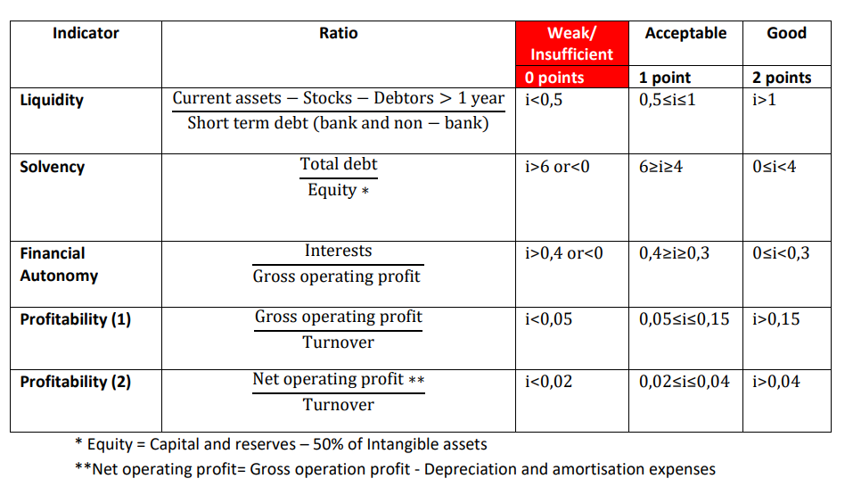
On the basis of the sum of the points for the five financial indicators, the entity’s financial capacity is considered positive (= good or acceptable) or negative (= weak or insufficient). The financial capacity is negative if the total score of the last year available does not exceed 3.
The overall financial capacity assessment result has been summarised in the table below:


Regulation (EU, Euratom) 2024/2509 of the European Parliament and of the Council of 23 September 2024 on the financial rules applicable to the general budget of the Union (recast) (‘ EU Financial Regulation’) (OJ L, 2024/2509, 26.9.2024).
As of 1 January 2028

