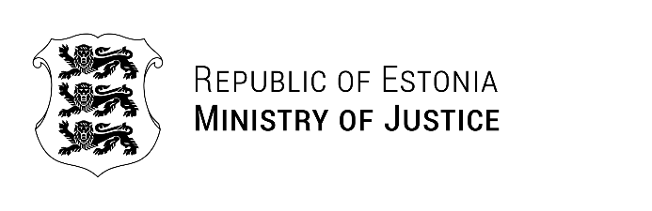

Our Ref: 24.09.2024 | No 7-2/6095
Mr Viorel Sochirca
Director
National Probation Inspectorate
Republic of Moldova
probatiune@probatiune.gov.md
MD‐2009,mun ChisinXau,Str.Vasilc Alccsalldri,nr.1

Letter

Dear Mr Sochirca,

Thank you for your kind words and interest in collaborating with the Estonian Probation Service. We greatly appreciate your proposal for a Memorandum of Cooperation.

At this stage, we believe a less formal approach, such as the upcoming study visit provides an excellent opportunity to thoroughly explore potential areas of cooperation, such as electronic monitoring, probation programs, and penitentiary probation. This will allow us to gain a deeper understanding of each other's practices and identify specific areas where a formal partnership could be mutually beneficial before formalizing a memorandum.

We are confident that your visit will be a valuable first step towards establishing a fruitful and mutually beneficial partnership in the future.

Sincerely,

Rait Kuuse
Deputy Secretary General on Prisons Department
Ministry of Justice

