**Autodrom 23x13m  
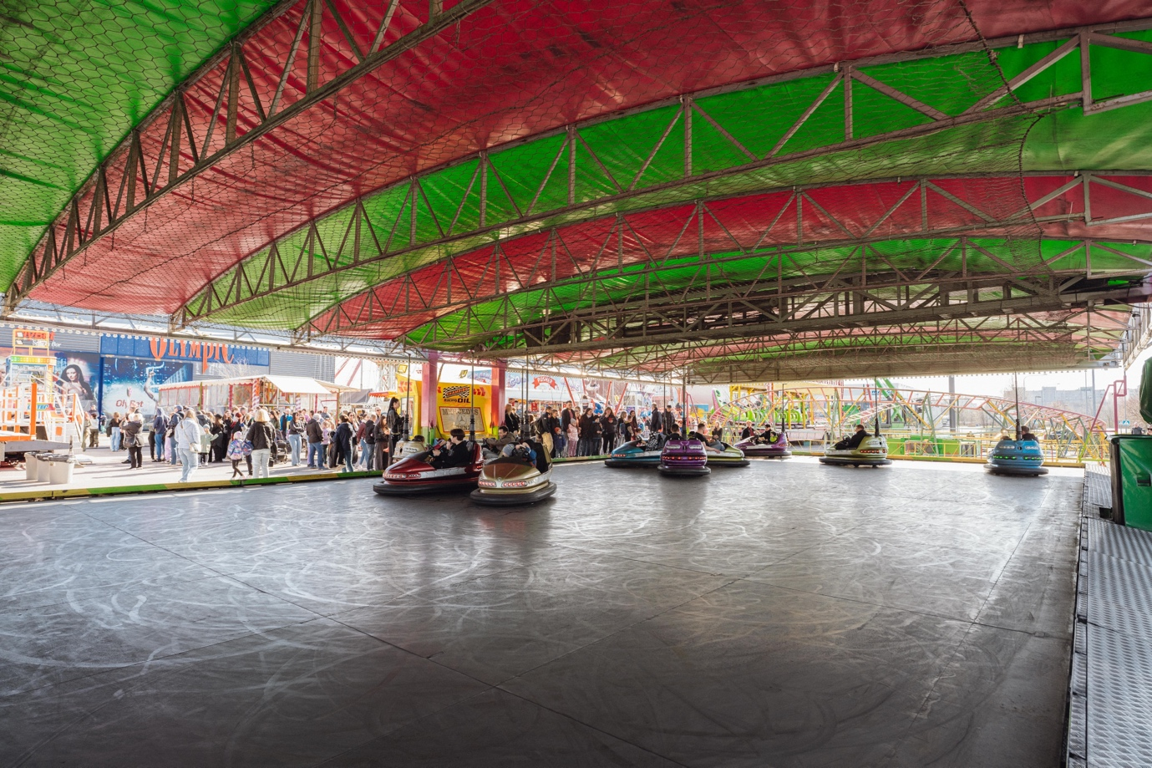**

**Batuut 8x10m**

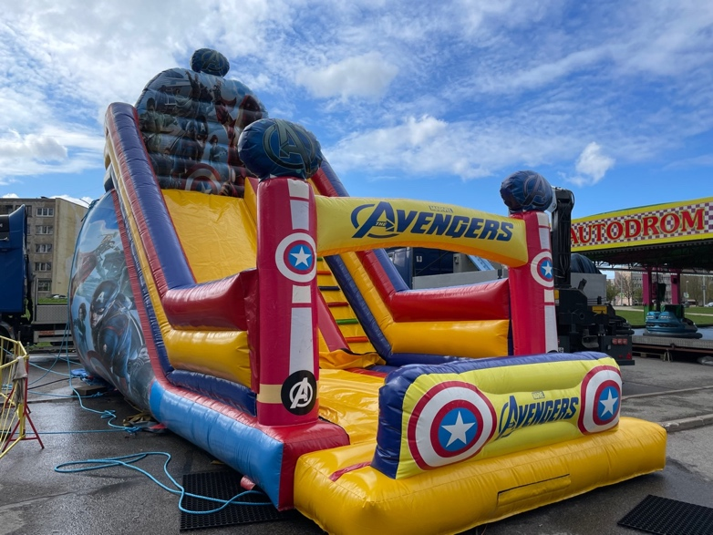

**Extreme 13x15m**

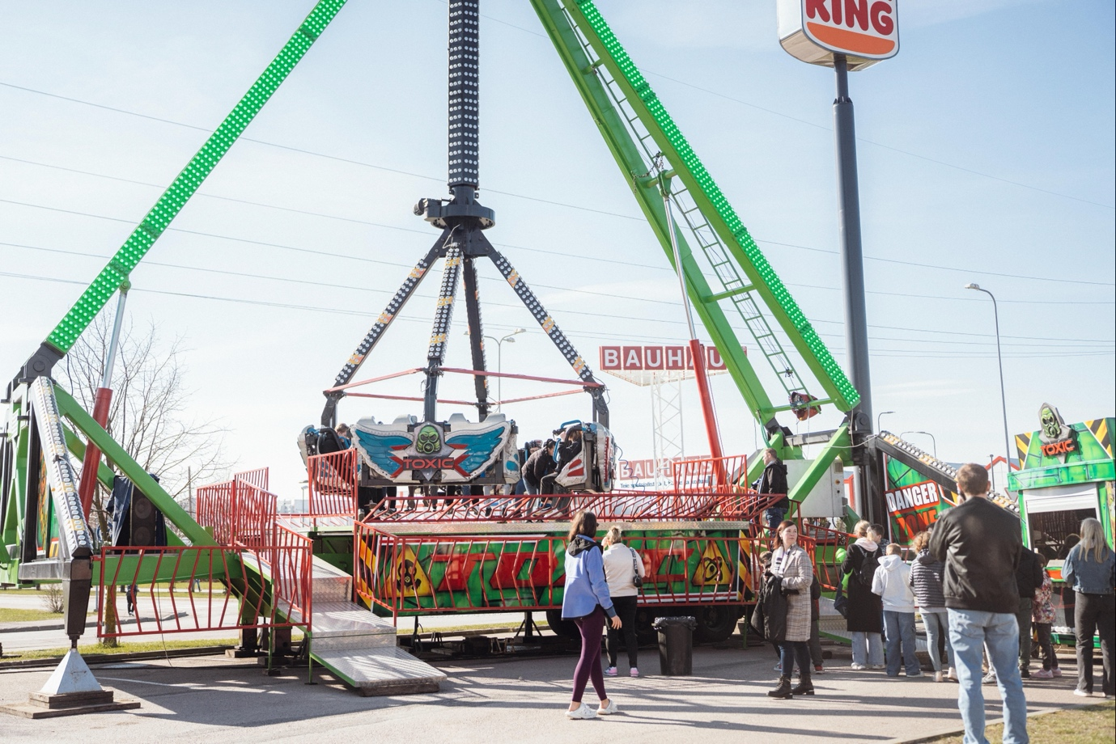

**Luiged 15m diameeter**

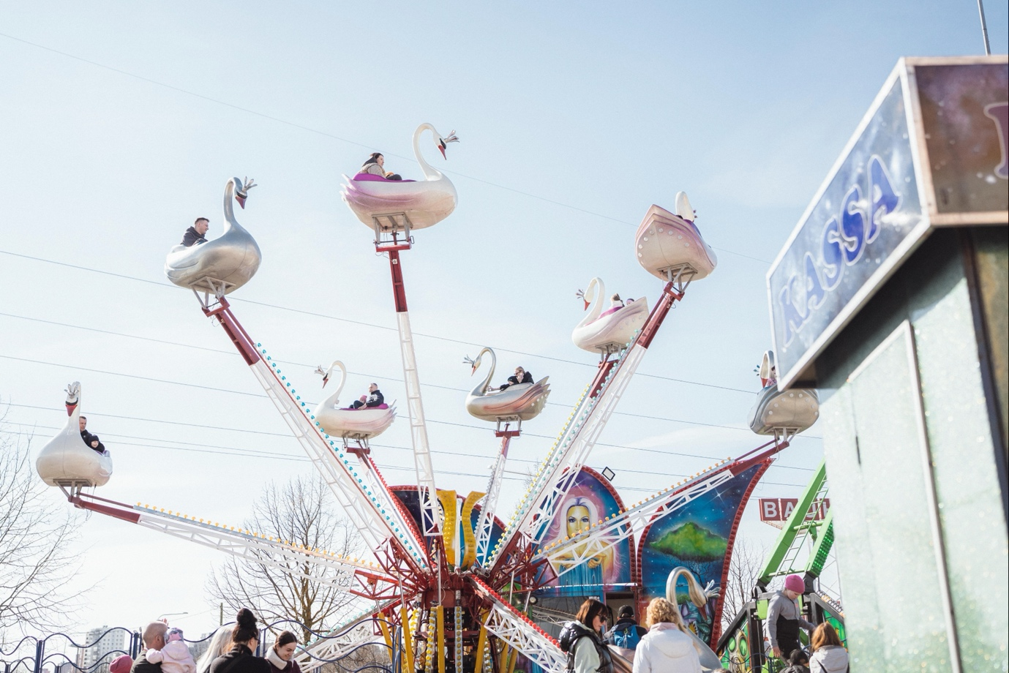

**Shrek 31x15m**

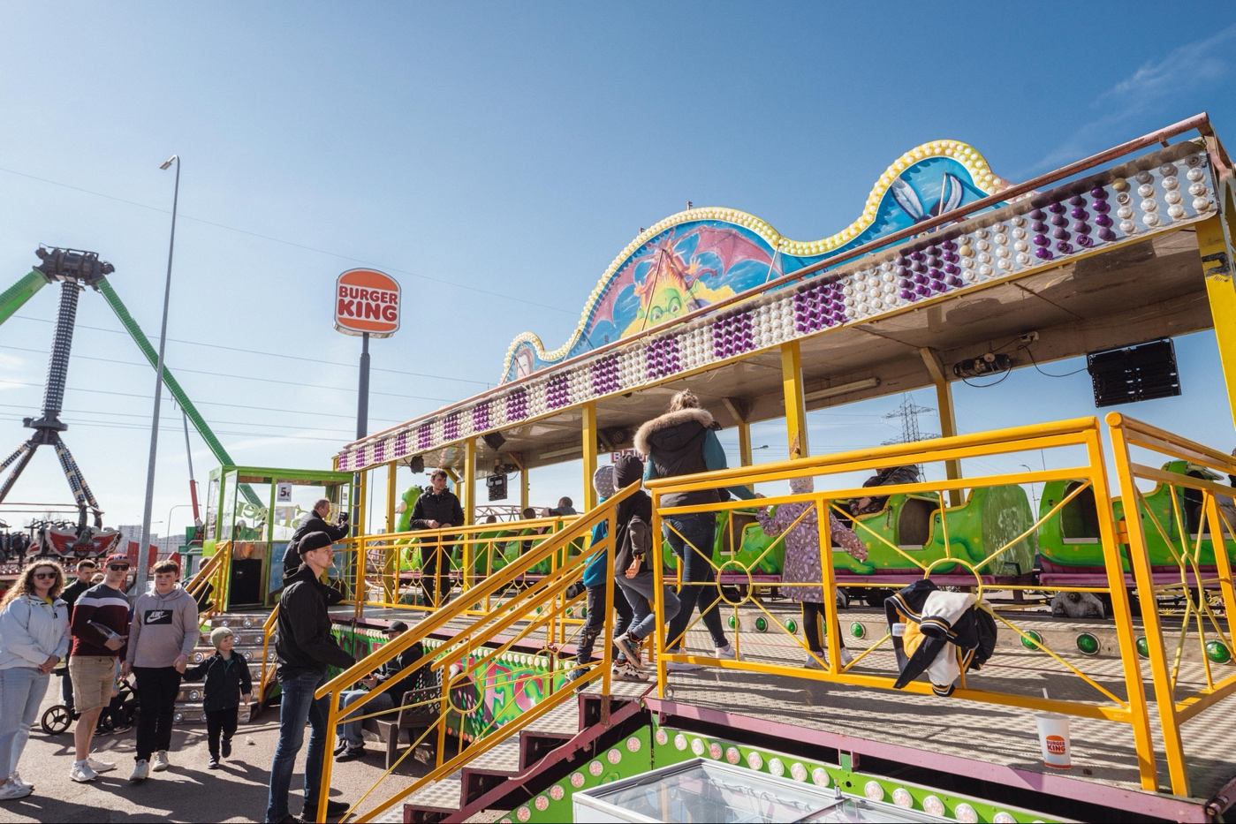

**Sky jump 10x10m**

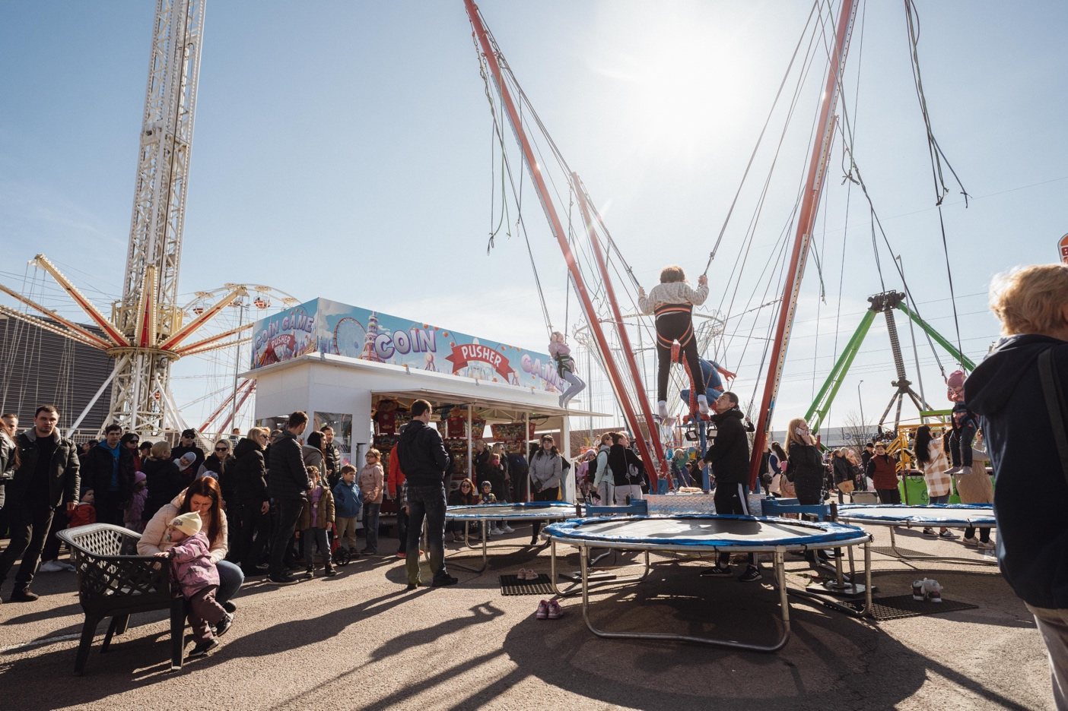

**Avengers 15x8m  
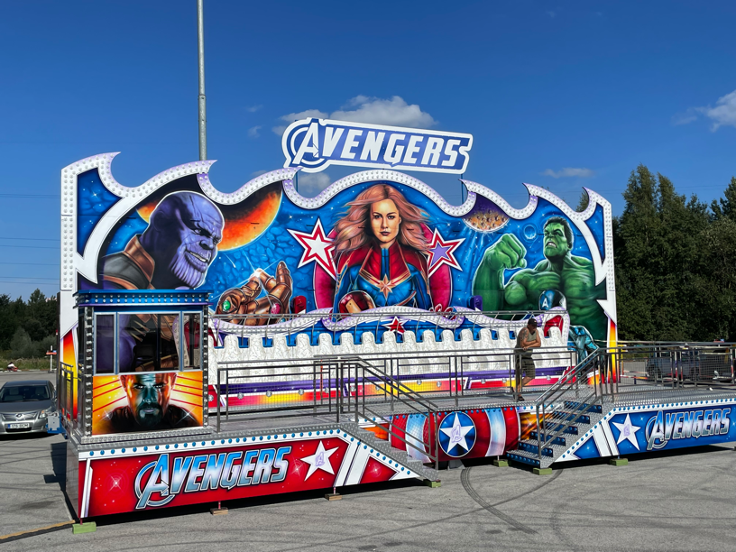**

**Labirünt 7x7m**

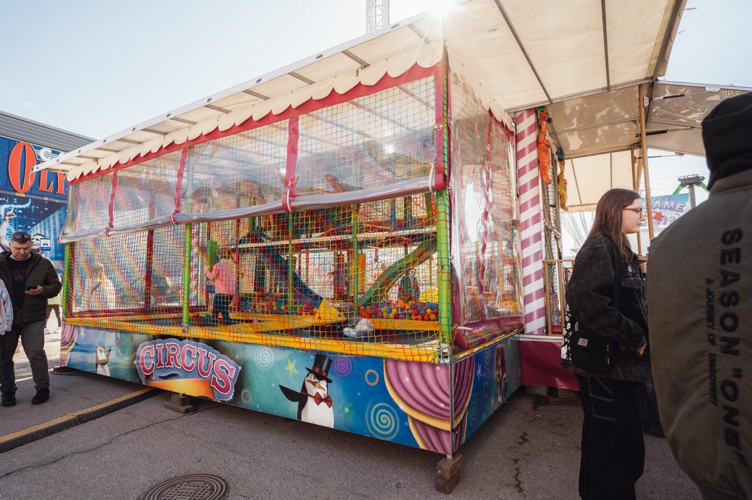

**Maneez 3.5x3.5m**

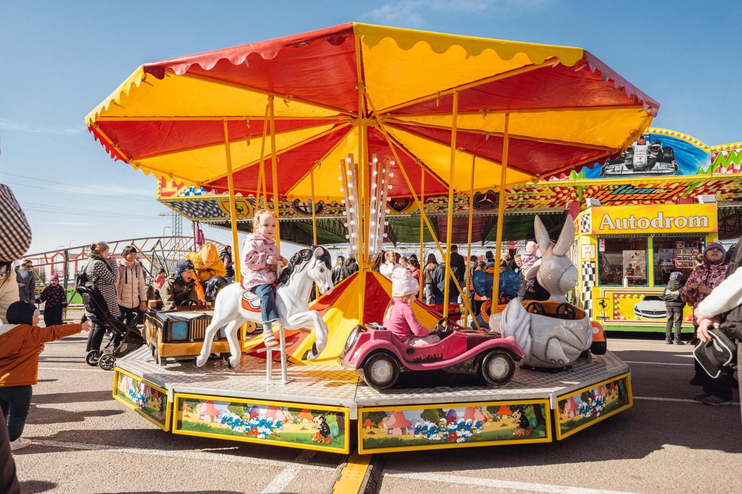

**Space mission 5.5x5.5m**

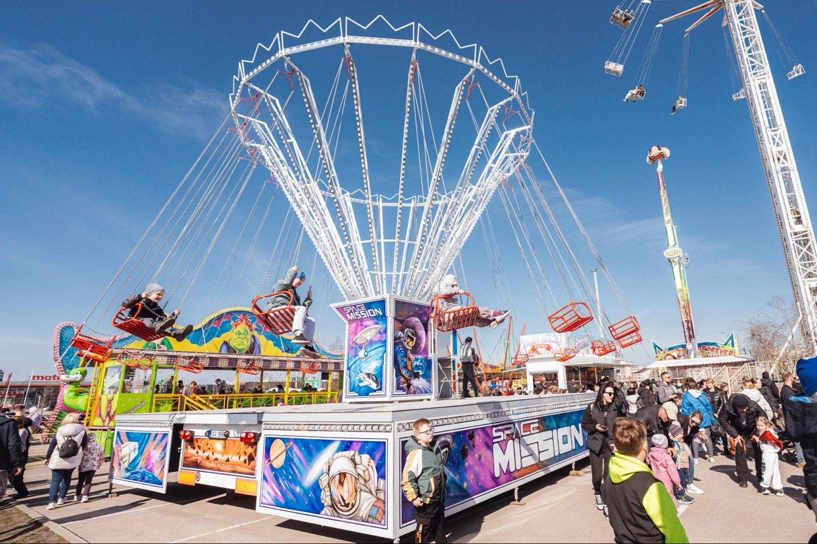

**Põgenemistuba 10x3m**

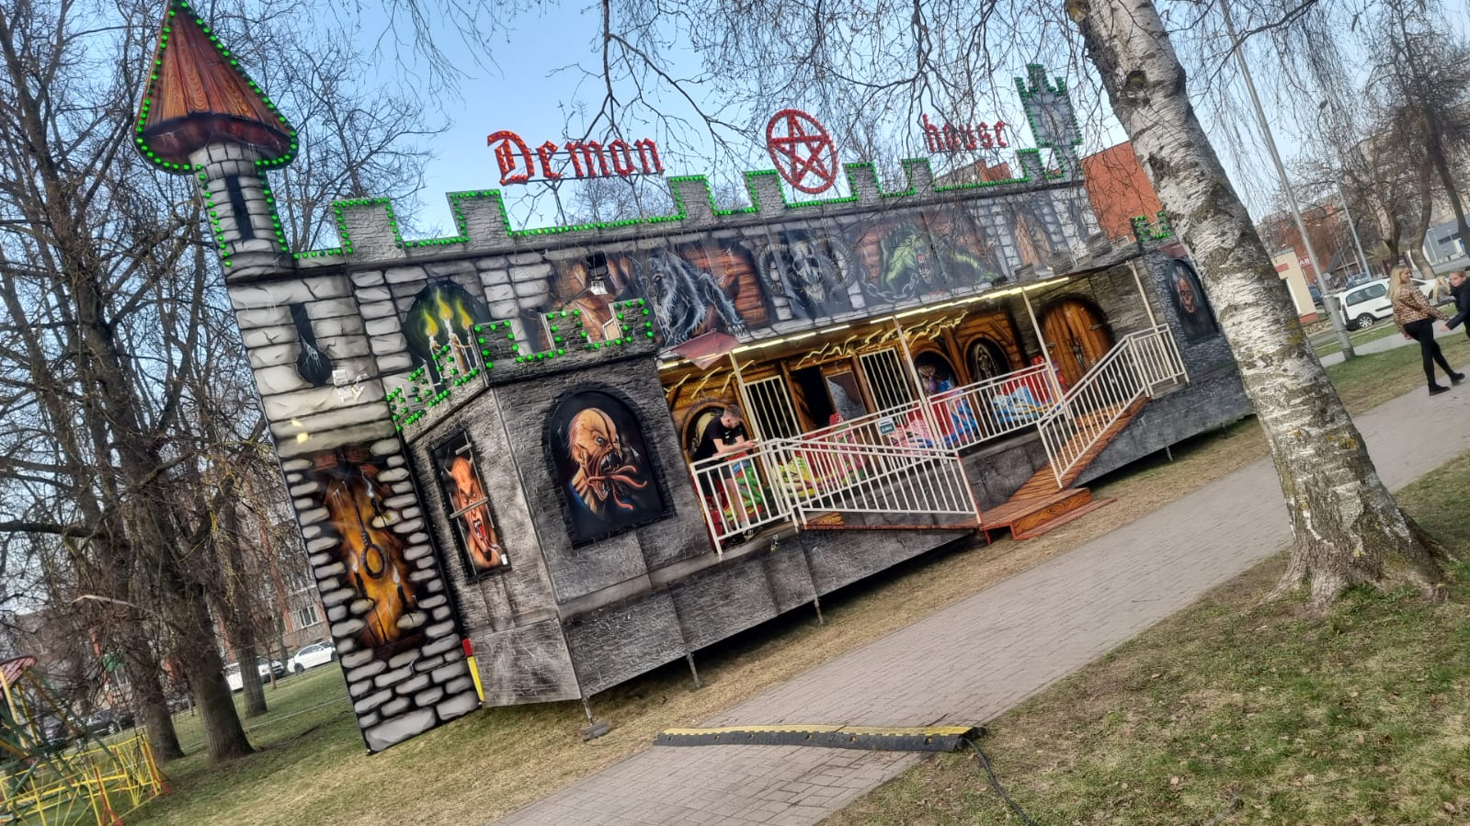

**B**

**Booster 20x7m**

