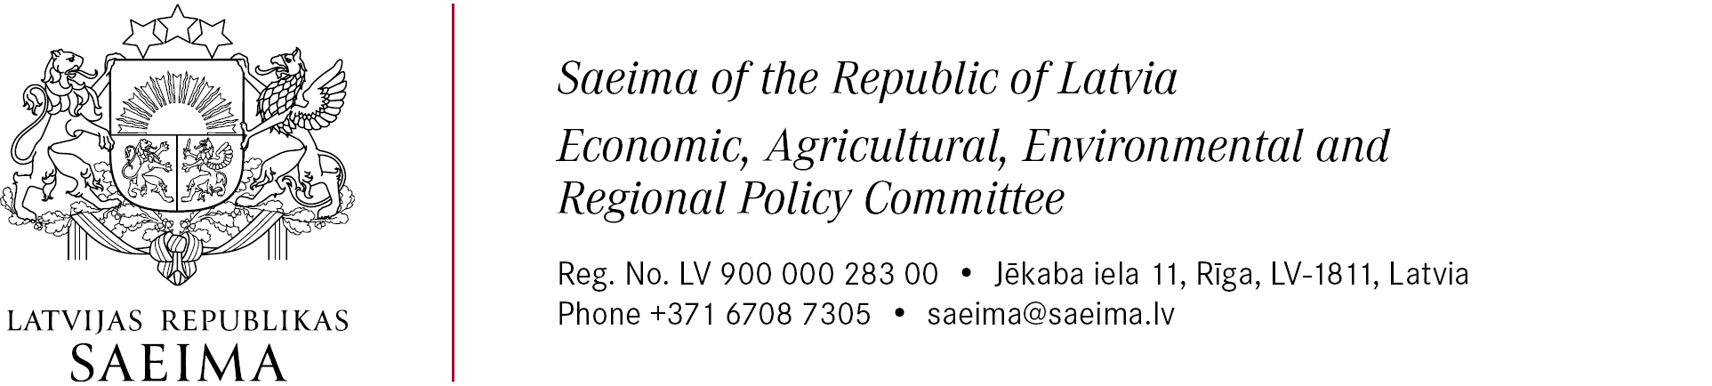

15th of May 2026
Nr. 142.1.9/8-9-14/26
Marek Reinaas
Chairman of the Economic Affairs Committee
Dear Colleagues,
On behalf of the Economic, Agricultural, Environmental and Regional Policy Committee of the Saeima of the Republic of Latvia and the Latvian Delegation to the Baltic Assembly, we are pleased to invite you and Members of your Committee to a joint meeting of the economic affairs committees of the Baltic States parliaments, which will take place on 29 May 2026 at the Saeima of the Republic of Latvia in Riga.
The meeting will be held from 09:30 to 11:30 and will focus on current economic and regional development issues of common relevance to the Baltic States, including matters related to Rail Baltica project and energy security, resilience and strategic infrastructure development in the present geopolitical environment.
Following the joint meeting we are planning an international energy policy event titled “Energy Independence in the Baltics – Shared Responsibility and Opportunities”.
The planned event aims to bring together parliamentarians, energy experts, industry representatives and other stakeholders from the Baltic States and Nordic countries to discuss the resilience and security of the Baltic energy system. Current work on the programme foresees thematic discussions on energy system design as the foundation of resilience and security, renewable energy integration from the perspective of system security, balancing capacities, balanced energy generation portfolios, as well as the role of society in strengthening energy security and resilience against disinformation in the energy sector.
We would also be honored by your participation in the official dinner to be held on 28 May 2026 at 19:00.
Please inform us about your participation by 22 May 2026 at the latest.
We look forward to welcoming you to Riga.

Chairman of the Economic, Agricultural, Environmental and Regional Policy Committee (signature*) Kaspars Briškens
* This document has been electronically signed with a secure electronic signature and contains a time stamp

