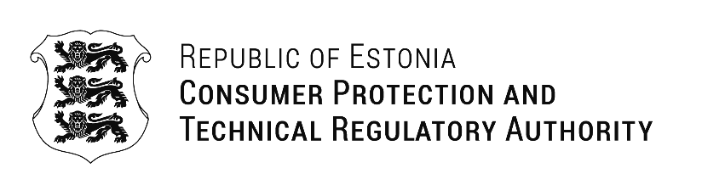
Mr. Pachara Siriborirak  National broadcasting and telecommunication commission (NBTC)  87 Phaholyothin 8 (Soi Sailom), Samsen Nai, Phayathai,  10400, Bangkok  Thailand | Our Ref: 14.08.2025 No 1-9/2025/0870
Invitation
Dear Mr. Pachara Siriborirak

The Consumer Protection and Technical Surveillance Authority (CPTA), , known in Estonian as Tarbijakaitse ja Tehnilise Järelevalve Amet, is a government regulatory agency established on 1 January 2019 by merging the former Consumer Protection Authority and the Technical Regulatory Authority
We would like to extend an invitation to you to visit Estonia between 3rd September, 2025 to 4th September, 2025 to exchange ideas and experience on DAB+ digital radio roll out so far in Estonia. We will discuss the power of broadcast digital radio in delivering high-quality news, fresh formats, and captivating content. Additionally, we will explore the economic, social, and sustainable benefits of DAB+.
Furthermore, we would like to suggest that you take the opportunity to participate and connect with the various radio stations in Estonia. These content providers have extensive experience in deploying DAB+ across the country and can offer valuable insights. My team and I would be happy to introduce you to them.
Please let me know if you require any further information to assist you.

Yours sincerely,

Erko Kulu
Head of Spectrum Management Division
on behalf of Head of Electronic Communication Department

+372 6672120 erko.kulu@ttja.ee

